4/23/2020

Abhilash Bahl

ANALYSING USED VEHICLES DATASET

PREDICTIVE ANALYTICS USING SAS

Table of Contents

INTRODUCTION 2

DATA DESCRIPTION 2

PREPROCESSING DATA 3

EXPLORATORY DATA ANALYSIS 7

IMPUTING MISSING VALUES FOR CYLINDERS, MODELS, MANUFACTURERS, ODOMETER; 7

RESTRICTING PRICE AND YEAR TO A LIMIT: 9

DROPPING VARIABLES WITH A HIGH PROPORTION OF MISSING VALUES: 12

DISTRIBUTION OF VARIABLES AFTER IMPUTATIONS AND REMOVAL OF NULL VALUES: 12

CONVERTING NUMERICAL VARIABLES TO CATEGORICAL VARIABLES: 17

EMPIRICAL ANALYSIS 19

RUNNING MODELS: 20

BINARY MODEL (FIRST): 20

NOMINAL MODEL (SECOND): 24

NOMINAL MODEL (THIRD): 27

NOMINAL MODEL (FOURTH): 30

ORDINAL MODEL-Adjacent Category-Stepwise selection (FIFTH): 33

ORDINAL MODEL-Adjacent Category (SIXTH): 37

ORDINAL MODEL- Cumulative (SEVENTH): 41

CONCLUSION 45

# INTRODUCTION

Craigslist is the world’s largest collection of used vehicles that are to be sold. This dataset is complex, and it is hard to maintain uniformity across all the parameters that are used in this dataset. This dataset contains reporting from the United States for our use. Other than this, the report contains information about all the variables after necessary analysis is done and the important variables have been picked up to continue forward.

# 

# DATA DESCRIPTION

There are a total of 25 variables by which a new listing is included and a total of 539759 observations. For this report, we have not used all the 25 variables but instead we have picked up a handful of variables from the ones that are available to come up with a model that is a best fit for this data set after exploratory data analysis.

The 25 variables along with their descriptions in this data set are:

1. Id; unique identifier for each listing
2. Url; contains the link to listing on Craigslist website
3. Region; defines which region in the United States the listing is from
4. Region_url; contains the link to listing by region
5. Price; price of the vehicle in the listing that is posted
6. Year; year of the manufacture of the vehicles
7. Manufacturer; name of the vehicle manufacturer
8. Model; name of the model of the vehicle
9. Condition; defines condition of the vehicle posted by user
10. Cylinders; number of cylinders in the vehicle’s engine
11. Fuel; type of fuel on which the vehicle runs
12. Odometer; number of miles travelled by the vehicle when the listing was posted
13. Title_status; title status as posted by the user
14. Transmission; information about the transmission of the vehicle
15. Vin; contains the vehicle identification number
16. Drive; information of the type of drive of the vehicle
17. Size; size of the vehicle
18. Type; type of the vehicle
19. Paint_color; color of the vehicle
20. Image_url; link to the images posted by the user
21. Description; a short description added by the user
22. County; useless column (no values found)
23. State; state in which the listing was reported
24. Lat: latitude of the location where listing was posted
25. Long; longitude of the location where listing was posted

# 

# PREPROCESSING DATA

Many variables in this dataset had a large number of incomplete/missing values. Few of these variables did not contribute to the overall analysis of this dataset. These variables were dropped before beginning the initial analysis. The variables which were dropped at this step are: url, region_url, lat, long, description, county, image_url.

A basic list about the number of unique values, percentage/number of missing values, various categories in each variable is reported here.

1. ‘Model’ has 32980 unique values and 2.48% missing values from the total in this dataset. It can be seen that the variable ‘model’ contains a lot of unique values. We have attempted to impute a few of the missing values to improve the quality.
2. ‘Cylinders’ has a total of 8 categories of the number of cylinders. The number of cylinders in this dataset are 3, 4, 5, 6, 8, 10 and 12. There are 40.48% missing values for this particular variable. We have attempted to impute some of the missing values to retain more number of observations for our analysis.

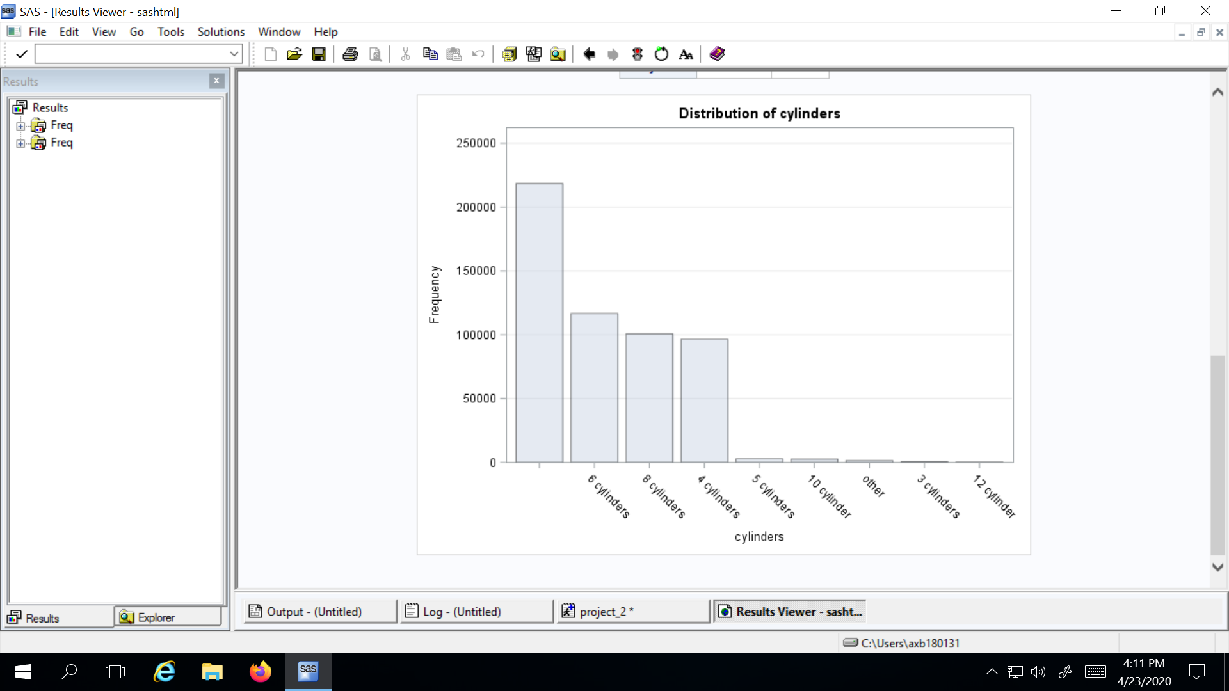

Figure 1

1. ‘Region’ has a total of 388 unique values which means that this dataset contains listings from a total of 388 regions across the United States. It is also found that there are no missing values for this particular variable. The top 10 regions are shown below.

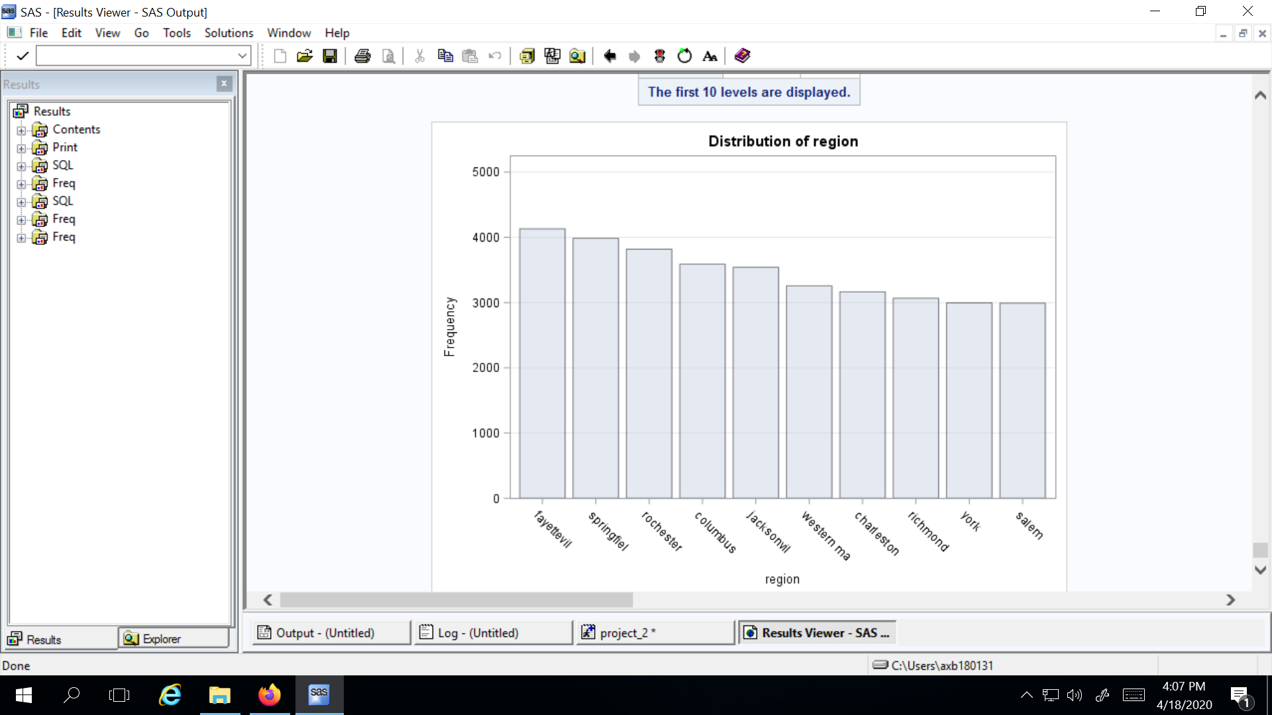

Figure 2

1. ‘Fuel‘ has a total of 5 different categories in this dataset. The different type of fuel that is used by the vehicles in this dataset is: Diesel (8.2%), Electrical (0,2%), Gas (86.91%), Hybrid (0.79%), Other (3.28%). There are 0.63% missing values for this variable.
2. ‘Condition’ has 6 different types of vehicle conditions included in this dataset. The type of conditions are; excellent, fair, good, like new, new and salvage. There are 43.73% missing values. We have decided to drop this variable from our analysis,
3. ‘Title_status’ has a total of 6 different categories in this dataset. The different categories are: Clean (95.21%), Lien (0.6%), Missing (0.13%), Parts Only (0.04%), Rebuilt (2.41%), Salvage (1.07%). There are 0.54% missing values for this variable.
4. Transmission’ has 3 different categories in this dataset. The different categories are Automatic (88.18%), Manual (6.48%), Other (4.61%). There are 0.74% missing values in this dataset.
5. ‘Drive’ has 3 different categories in this dataset. These categories are 4wd (33.09%), fwd (24.67%), rwd (13.39%). There are 28.86% missing values in this dataset.

1. ‘Manufacturer’ contains listings of 43 unique manufacturers and has 4.37% missing values in this dataset. We have attempted to impute quite a few of these missing values in this dataset to improve the overall quality. A distribution of listings from top 10 manufacturers is shown below.

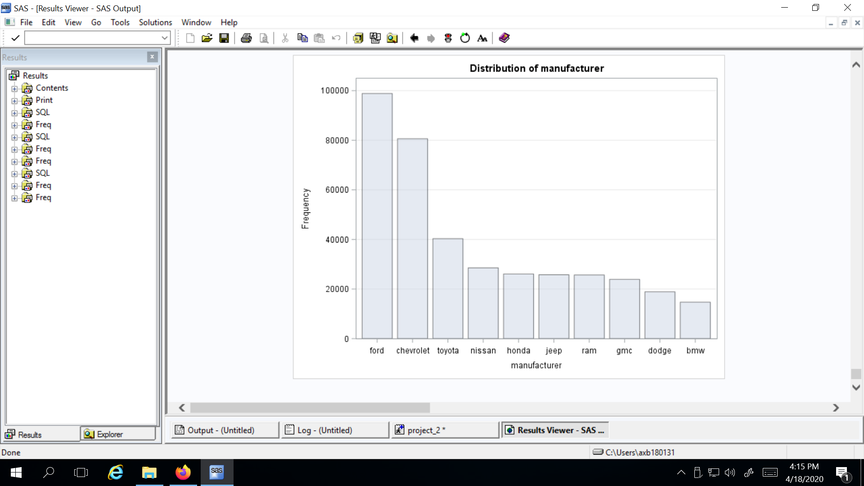

Figure 3

1. ‘Size’ has 4 different categories in this dataset. These categories are: Compact (4.63%), Full-size (17.15%), Mid-size (8.71%), Sub-compact (0.73%). There are 68.77% missing values. Size has the largest proportion of missing values among all the variables, we have decided to drop ‘size’ from further analysis.
2. ‘Type’ has 13 different vehicle types in this dataset. The types of vehicles are: SUV (17.53%), bus (0.11%), convertible (1.68%), coupe (4.01%), hatchback (2.74%), mini-van (1.24%), offroad (0.15%), other (3.40%), pickup (10.36%), sedan (17.81%), truck (9.34%), van (2.04%), wagon(2.26%). There are 27.32% missing values for this variable.
3. ‘Paint_color’ has 13 colors of the vehicles listed in this dataset. The different colors are: black ( 13.71%), blue (6.90%), brown (1.53%), custom (1.71%), green (1.77%), grey (6.46%), orange (0.45%), purple (0.17%), red (6.75%), silver (10.09%), white (17.70%), yellow (0.49%). There are 32.28% missing values for this variable.
4. ‘Id’ has no missing values across this dataset. It contains a unique id for each listing on craigslist.
5. ‘State’ has no missing values and the maximum number of listings are found in the state of California (10.22%). A distribution of listings from top 10 states by proportion is shown below.

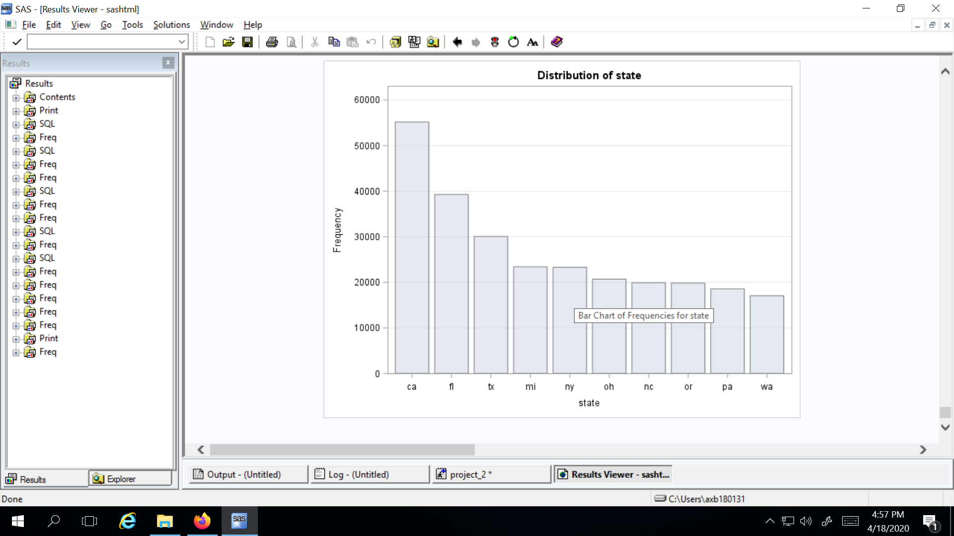

Figure 4

1. ‘VIN’ has 224371 missing values which accounts for approximately 41.56% missing values for this variable. Upon further analysis it is found that not all the values of VIN are unique for each listing. There are some errors with reporting of values for this variable on users end and we have decided to drop this variable from further analysis.
2. ‘Odometer’ has a total of 98976 missing values which account for approximately 13.34% of missing values for this variable. We have attempted to impute few values for odometer to reduce the number of missing values which has helped in improving the quality of the data.
3. ‘Price’ has a total 44689 missing values which accounts for 8.28% missing values in this dataset.

# 

# 

# 

# EXPLORATORY DATA ANALYSIS

## IMPUTING MISSING VALUES FOR CYLINDERS, MODELS, MANUFACTURERS, ODOMETER;

First, the variable ‘**cylinders**’ was considered. Missing values for cylinders previously were 40.48%. We noticed that even the same model of car could have different numbers of cylinders. For example, one third of the car model ‘grand cherokee’ had 8 cylinders and two third had 6 cylinders.

The proportion of models having a particular type of cylinder was calculated. Based on that proportion the value of the number of cylinders was imputed in the data. For example, one third of the observations with missing cylinder value of ‘grand cherokee’ were imputed with ‘8 cylinders’ and two third with ‘6 cylinders’.

Likewise, the proportion of each cylinder category was calculated for 35 models and then in the same proportion the missing values were imputed. Imputing the values proportionately will not introduce any bias in the data. A snippet of the code used for this purpose is shared here.

*proc sql;*

*update work.vehicles1 set cylinders = '8 cylinders' where cylinders=' ' and model in ('grand chero','tacoma','3500') and id > 7065764796 and id < 7075022102 ;*

*update work.vehicles1 set cylinders = '6 cylinders' where cylinders=' ' and model in ('grand chero','tacoma','3500') and id > 7075022102 and id < 7093536715 ;*

*run;*

Second, many values for the ‘**model**’ of the vehicles are updated. There are some errors when the name of the model is reported by the user. For example; model ‘Corolla’ is reported as ‘/Corolla’, ‘*corolla’, ‘-COROLLA’. Through imputations, we have attempted to generalise the name of the model to ‘Corolla’ which would improve the classification and reduce the number of unique models in the dataset as there are a lot of unique values present and tracing each unique value individually can be difficult.

Second example for the errors associated with the model name is reporting the year of manufacture of the vehicle before the model name. For example; ‘04 Altima’, ‘10 Altima’, ‘12 Altima’ are changed to ‘Altima’, which has made it easier for us to classify all the models named ‘Altima’.

Another example of errors with the model name is reporting of model name in different fonts. Either the name is reported in capital letters or small letters, which is read as a separate unique value while using PROC FREQ to identify the number of missing values and other parameters. These values are changed to a common format such as ‘Civic’ from ‘CIVIC’ or ‘civic’. These imputations are performed using PROC SQL statements and an UPDATE statement in the PROC SQL command. An example of such imputation is given below.

*proc sql;*

*update work.vehicles1 set model = 'Passat' where lower(model) like '%passat%'; quit;*

Here, vehicles1 is the name of the table that is imported from kaggle. ‘Vehicles1’ is imported in the work directory of SAS.

A total of 53,178 rows are updated here. The proportion of missing values before imputation was 2.48% which was reduced to 1.48% or 8005 rows which did not have a model name.

Third, for ‘**manufacturer**’ the proportion of missing values before imputation was 4.37%. For identifying the manufacturer of a particular model, we searched the name of the manufacturer by entering the model name on the internet. To identify the rows which did not have a manufacturer but a model existed we used PROC SQL with the following command.

*proc sql;*

*select manufacturer, model from work.vehicles1 where manufacturer is null;*

*quit;*

It was identified that there are a total of 23,584 rows with no value for the manufacturer variable. While looking at the list of the manufacturers, it was found that one of the manufacturer’s names was misspelled; ‘Porsche’ was spelled as ‘Porche’ and this was corrected using an UPDATE statement within the PROC SQL command. A total of 13 rows were updated through this.

It was also found that there are 195 rows containing the value ‘olet Silver’. No manufacturer was found for this particular model, instead it was identified that this is a part of the vehicle and this value was removed from the list of models. A total of 200,681 rows were updated using the UPDATE statement in PROC SQL command, which reduced the missing value percentage to 2.66% from 4.37%. The UPDATE statement was not only targeted at the missing values but the values with some minor errors were also corrected. We tried to generalize the most common occurring values. One example of such a statement used is given below.

*proc sql;*

*update work.vehicles1 set manufacturer = 'chevrolet' where lower(model) like '%camaro%' or lower(model) like '%corvette%'*

*or lower(model) like '%impala%' or lower(model) like '%mali%' or lower(model) like '%traverse%'*

*or lower(model) like '%camino%' or lower(model) like '%suburban%' or lower(model) like '%tahoe%'*

*or lower(model) like '%sonic%' or lower(model) like '%carlo%' or lower(model) like '%avalanche%'*

*or lower(model) like '%cruz%';*

*quit;*

Fourth, the values for the ‘**Odometer**’ variable were imputed as there were 98976 (13.34%) missing values. The odometer readings were classified according to year of purchase. A vehicle bought in the same year can be assumed to have run almost the same distance on an average. The average odometer reading calculated year wise and imputed it for vehicles bought in that particular year. After imputation, 98,403 rows were updated.

*proc sql;*

*update work.vehicles1 v1 set odometer= (select mean(odometer) from Odom1 v2 where v2.year=v1.year) where odometer is null;*

*run;*

## RESTRICTING PRICE AND YEAR TO A LIMIT:

After this, we took the variable ‘**price**’ into consideration since it is an important parameter in this dataset. It was found that there are some errors associated with the price listings. One such error was the user had missed a decimal point while listing the price of their vehicle. For example; a new Jeep Cherokee usually costs somewhere around $35,000 - $40,000. One such listing for the same vehicle had a price of $3250000, where according to us the user had missed a decimal point, the price for a used Jeep Cherokee which is $32500.00 is acceptable.

There were a total 162 vehicles in this dataset which had a price listing of more than $200,000 which meant that either the price has been reported incorrectly as shown in the above example or the vehicle belonged to a luxurious category with extremely high prices.

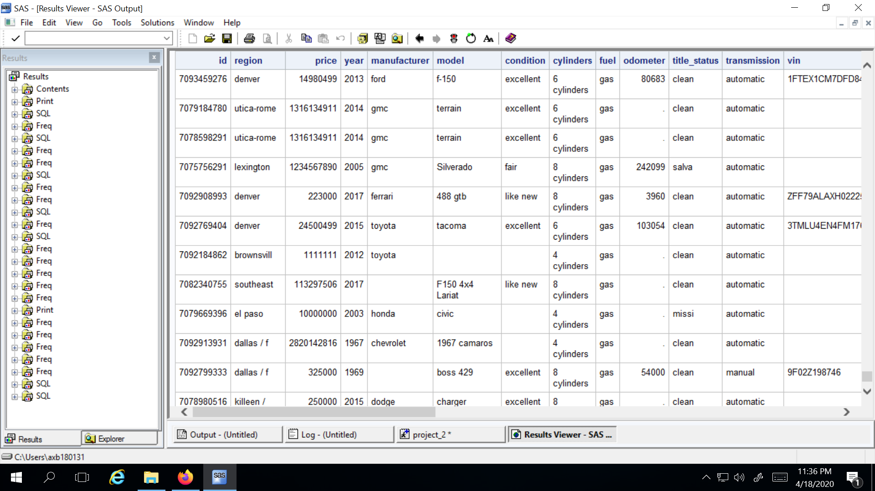

Figure 5

It was observed due to erroneous reporting of price and vehicles belonging to the luxury category had produced a very bad distribution of price across the dataset when seen through the PROC UNIVARIATE command. A histogram with such distribution is shown in Figure 6.

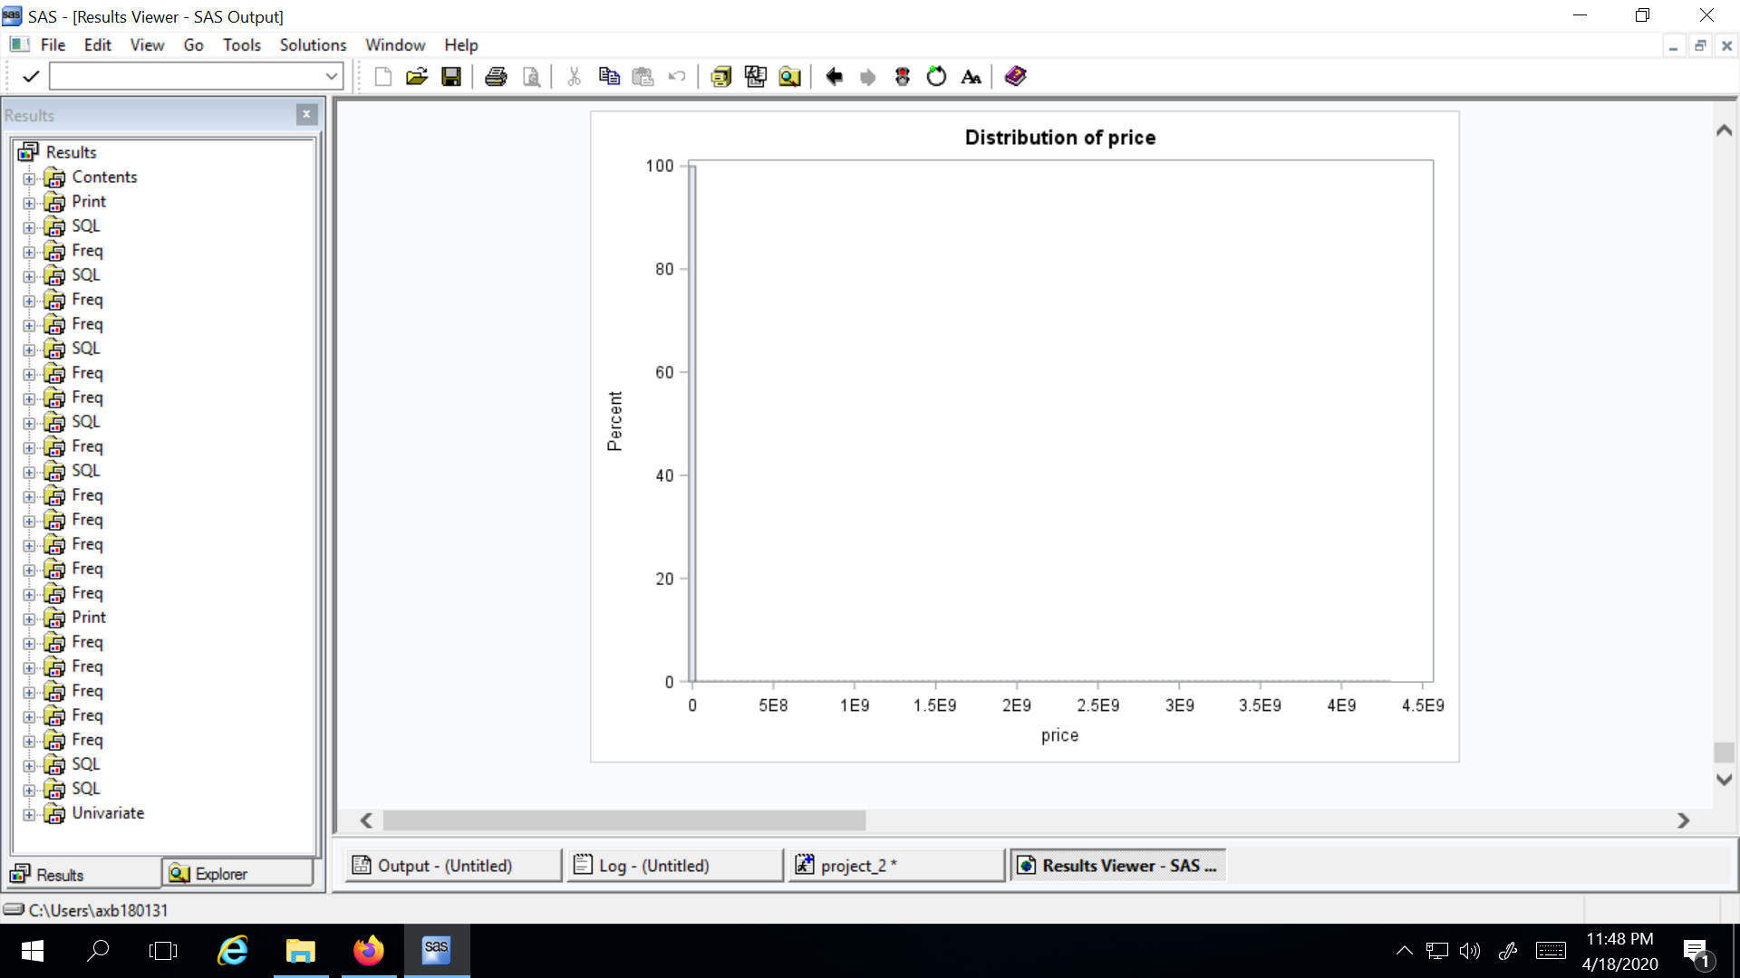

Figure 6

From this histogram, it can be observed that distribution of price is not good. To improve this, we excluded all the vehicles which had a listed price of more than $200,000. A total of 162 rows were deleted at this step. After that, a distribution of price upto $200,000 is produced to observe any improvements/changes in the distribution. This histogram can be found here (Figure 7).

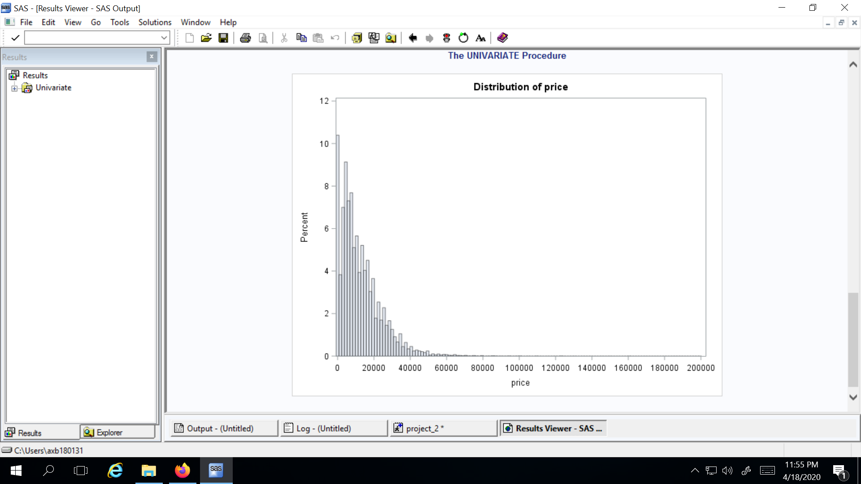

Figure 7

As it can be seen from this histogram, there are very few cars above $60,000 upto $200,00. Upon further analysis, it was found that there are 2570 vehicles have price of more than $60,000. This is making the mean price biased towards the higher end. We dropped these values to further limit the analysis to a specific price range and all the vehicles having a price of more than $60,000 were excluded from this dataset. After this, a distribution of price upto $60,000 is produced with intervals of $1000. This distribution is satisfactory for moving ahead with the analysis. (Figure 8)

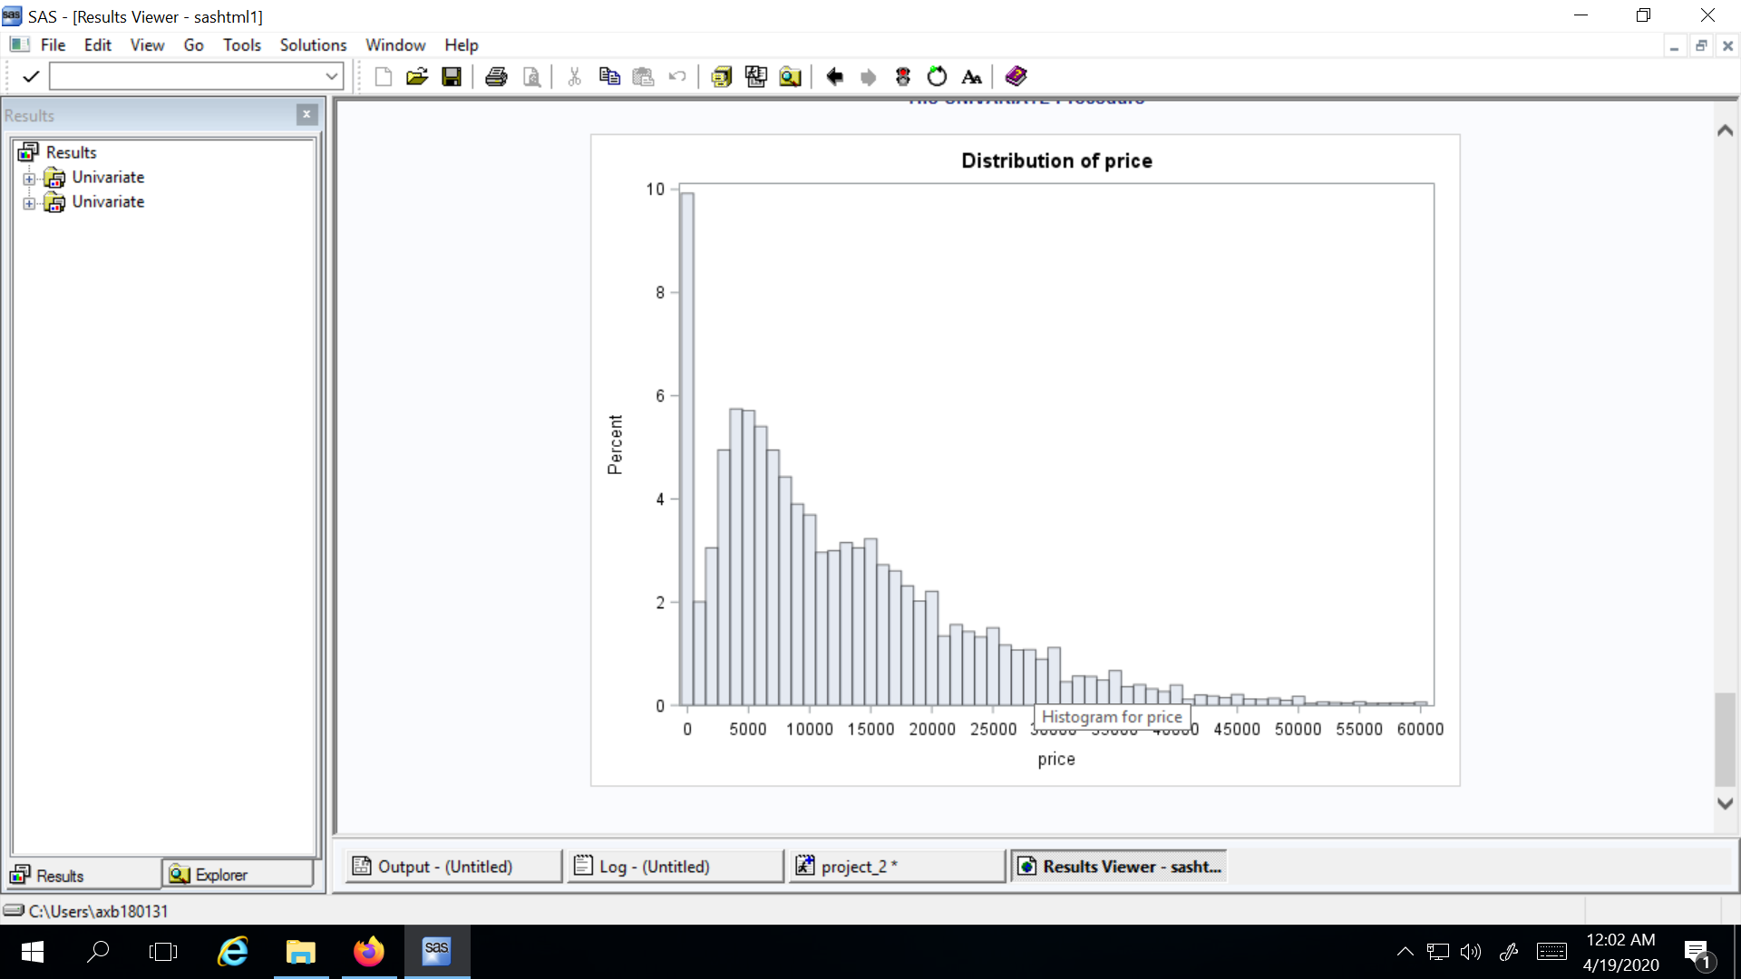

Figure 8

‘**Year**’ variable has 942 missing values. These missing values are dropped from the dataset. Furthermore, it is found that 100 vehicles have a listing year more than ‘2020’ which is not possible. We have limited our data to the year ‘1900’ on the lower end and ‘2020’ on the upper end. A total of 101 observations are dropped here.

*proc sql;*

*delete from work.vehicles1 where year IS NULL;*

*Quit; /* deleted those 942 values */*

*proc sql;*

*select count(*) from work.vehicles1 where year > 2020;*

*quit;*

*/* 100 entries having year greater than 2020. Deleting those rows */*

*proc sql;*

*delete from work.vehicles1 where year > 2020;*

*delete from work.vehicles1 where year < 1900;*

*quit; /* 101 rows deleted */*

## DROPPING VARIABLES WITH A HIGH PROPORTION OF MISSING VALUES:

Variables ‘**size**’, ‘**condition**’ and ‘**vin**’ were dropped from the dataset. All three of these variables had a very high percentage of missing values as reported earlier and ‘vin’ did not have unique values for each variable. It is not possible to impute values for ‘vin’ as it is a unique identifier for each vehicle, so to avoid discrepancy, we decided to drop this variable.

At this point, we are left with 535,978 observations and 15 variables in our dataset. We decide to drop all the null values across all rows to prepare the dataset for modeling, after our attempts at imputations and correcting errors. A snippet of the code used to drop these null values is shown below. Here we are left with 271,663 observations and 15 variables.

*data work.vehicles1;*

*set work.vehicles1;*

*if nmiss(of _numeric_) + cmiss(of _character_) > 0 then delete;*

*run;*

## DISTRIBUTION OF VARIABLES AFTER IMPUTATIONS AND REMOVAL OF NULL VALUES:

After all the null values have been dropped as per the last step, we will now take a look at the variables in the data set to observe how the distributions might have changed.

1. **Models**’ now has 17251 unique values as compared to 32980 unique values before imputations. All the missing values here have been dropped as compared to 2.48% earlier.
2. The distribution for ‘**region**’, ‘**state**’ stays the same as there were no missing values here that needed to be imputed or dropped from the data set.
3. The number of unique ‘**manufacturers**’ now is 47 which is an increase of 4, as there were 43 unique manufacturers earlier. There were new manufacturers that were added during imputation. A distribution of top 10 manufacturers by count is shown in Figure 9 for comparison.

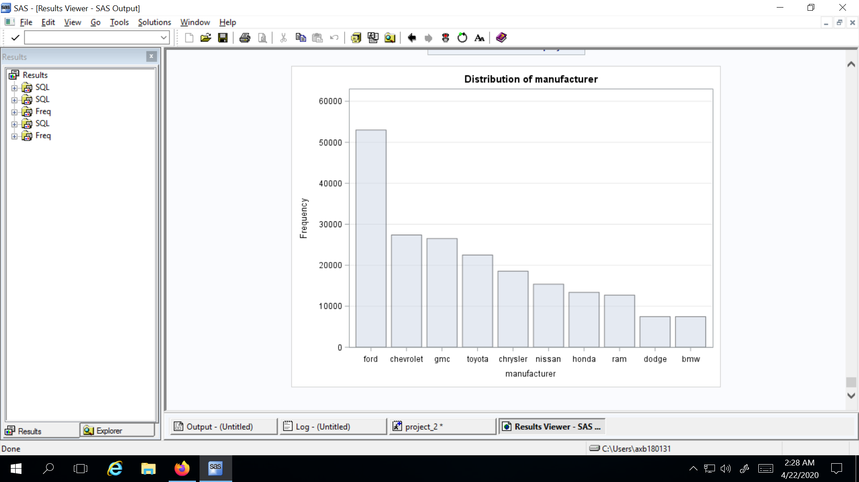

Figure 9

A shift can be seen in this distribution as ‘gmc’ and ‘chrysler’ now have a higher count, which means that imputation helped in identifying certain manufacturers through models.

1. There were values that were imputed for ‘**cylinders**’ which has produced the following distribution.

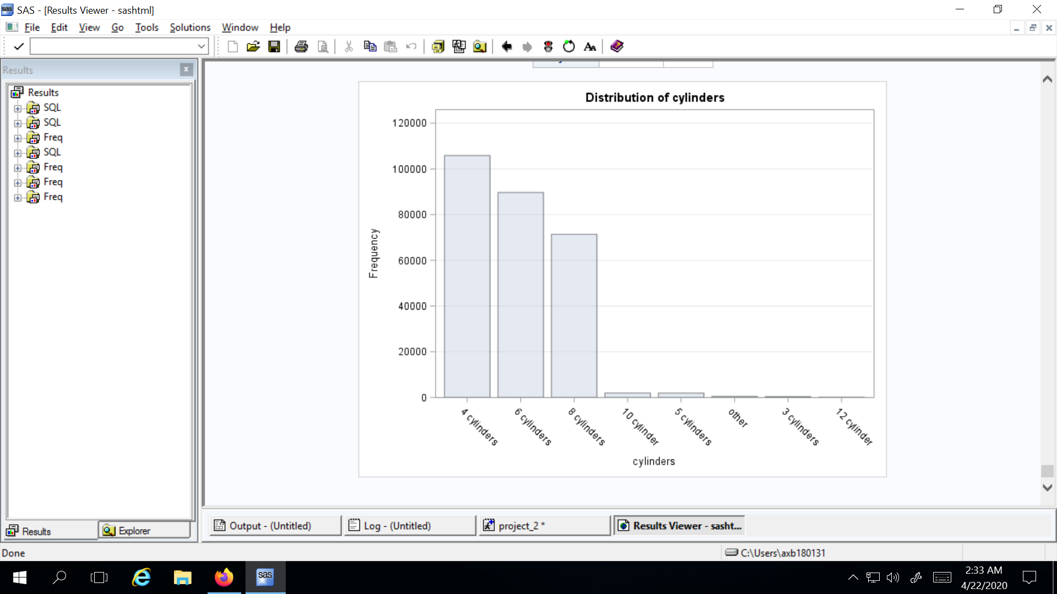

Figure 10

It can be seen from this distribution (Figure 10) that ‘4 cylinders’ have the highest count followed by ‘6 cylinders’ and ‘8 cylinders’ respectively. Previously, the majority of the rows had null values followed by 6, 8 and 4 cylinders respectively. After imputation, this distribution seems to have improved.

1. The distribution for ‘**fuel**’ stays the same with most vehicles being run on gas followed by diesel.

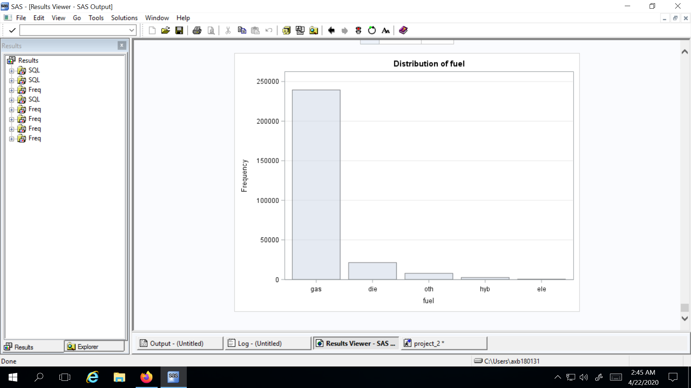

Figure 11

1. The distribution for ‘**title_status**’ also remains the same, with clean titles having the biggest proportion in this dataset followed by rebuilt titles.

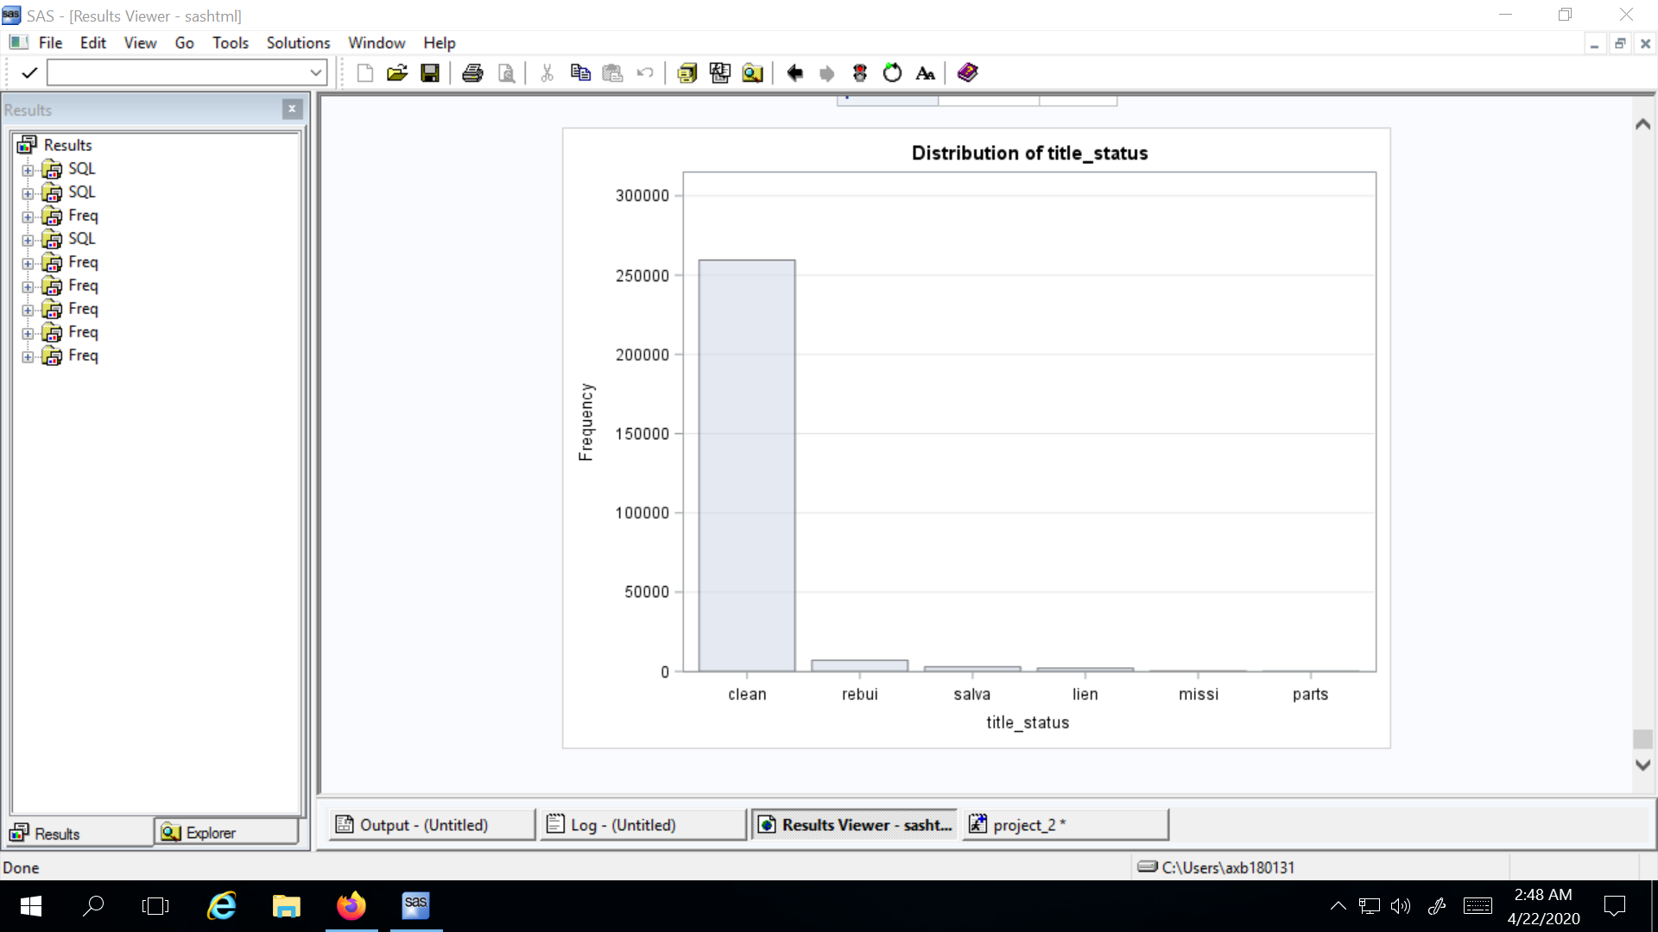

Figure 12

1. The distribution for ‘**transmission**’ also remains the same here, with maximum vehicles having automatic transmission followed by manual transmission.

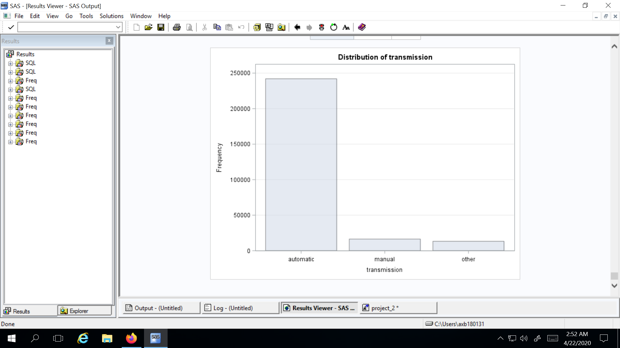

Figure 13

1. The distribution for ‘**drive**’ also remains the same. Here, 4 wheel drive has the highest proportion followed by forward wheel drive and rear wheel drive respectively.

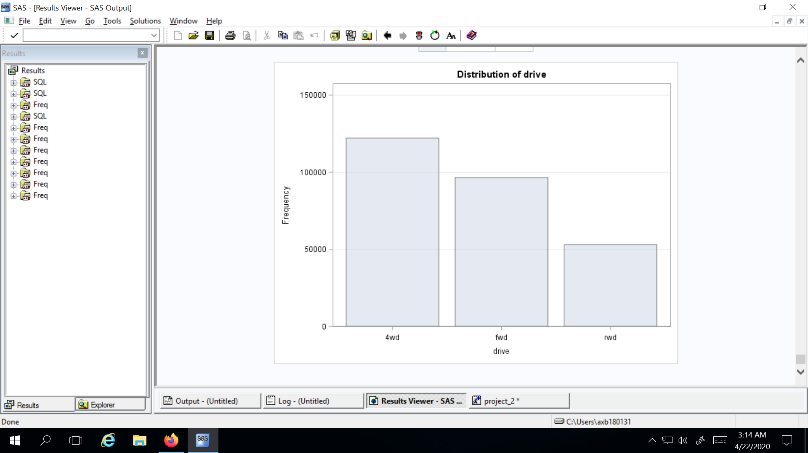

Figure 14

1. It can be seen from the distribution of ‘**type**’ of vehicles that sedans and SUVs have the highest proportion followed by trucks, pickup vehicles and other categories. This distribution remains almost similar with one noticeable change that is, now the number of trucks in this dataset are more compared to pickup vehicles.

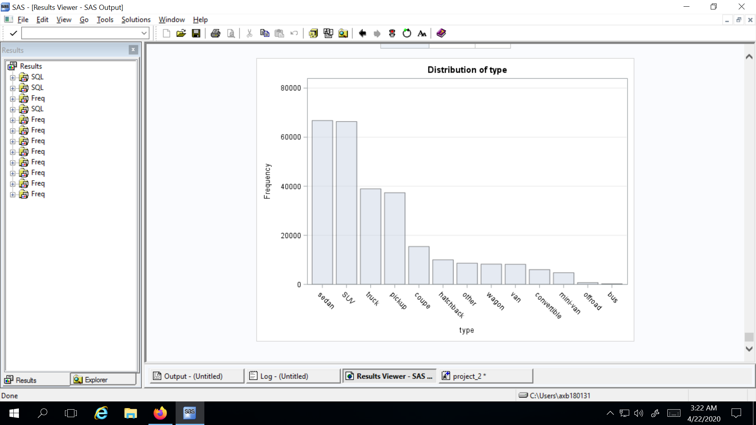

Figure 15

1. The distribution of ‘**paint_color**’ remains mostly the same. Most of the vehicles have white color followed by black. There is some slight change among red, blue and silver color after the null values have been ignored. The difference among these three is almost negligible.

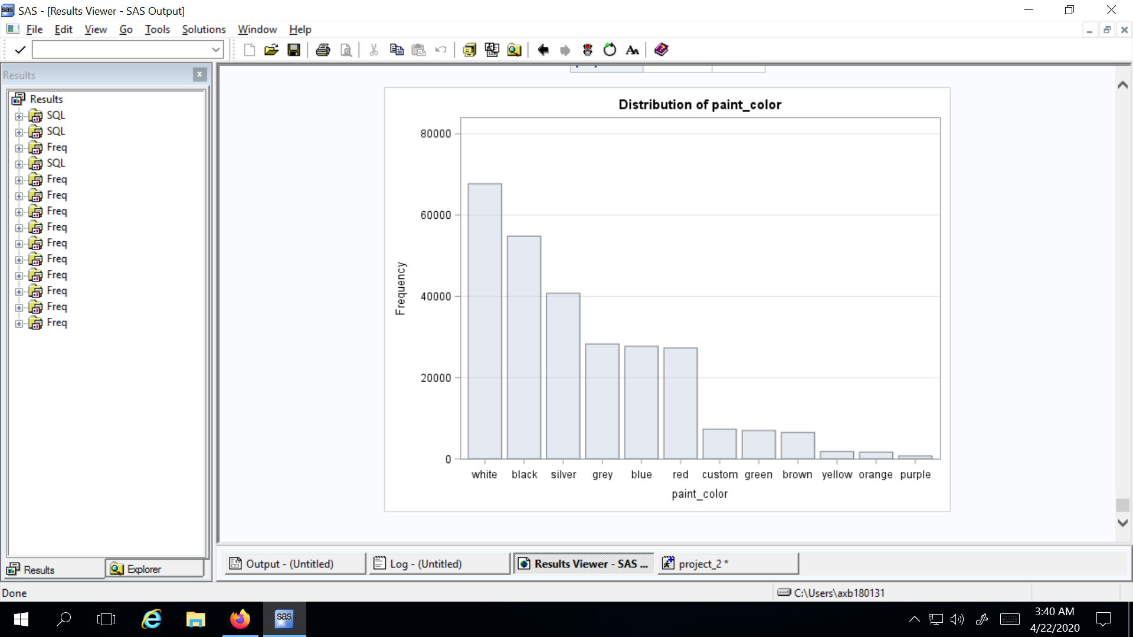

Figure 16

## CONVERTING NUMERICAL VARIABLES TO CATEGORICAL VARIABLES:

Odometer and price were originally numerical variables. Since, all the variables so far in this dataset are categorical, we have created three new categorical variables.

The first categorical variable that is created is for the **odometer** category named ‘**odo_cat**’. The categories for this were made using the PROC SQL command. As per our search on the internet, we found out that there were very few vehicles which had travelled more than 350,000 miles and this is true for the dataset that we are working on. Based on this, it was decided that odometer readings be broken down into six categories. The first category is ‘0-50,000’ and there is a 50,000 mile interval between each category with the last category having all vehicles which have travelled more than 250,000 miles. A snippet of the code that was used for this purpose is shared below.

*proc sql;*

*update work.vehicles1 set odo_cat='0-50000' where odometer<=50000;*

*update work.vehicles1 set odo_cat='50001-100000' where odometer<=100000 and odometer>50000;*

*update work.vehicles1 set odo_cat='100001-150000' where odometer<=150000 and odometer>100000;*

*update work.vehicles1 set odo_cat='150001-200000' where odometer<=200000 and odometer>150000;*

*update work.vehicles1 set odo_cat='200001-250000' where odometer<=250000 and odometer>200000;*

*update work.vehicles1 set odo_cat='>250000' where odometer>250000;*

*quit;*

Two types of categories were created for the **price** variable. The first type of category divided price into two categories so that we can use price as a binary variable while modeling. Whereas, the second type of category divides price into four categories. The intervals for these categories were decided by checking the percentile distribution of price.

*proc means data=work.vehicles1;*

*var Price;*

*output out=percentile P25= P50= P75= / autoname;*

*run;*

*proc sql;*

*update work.vehicles1 set price_cat1='reasonable' where price<20000;*

*update work.vehicles1 set price_cat1='expensive' where price>20000;*

*quit;*

This category is the binary version of the price that was mentioned above. (Also refer to the distribution of price in preprocessing data section)

*proc sql;*

*update work.vehicles1 set price_cat='L1' where price<6000;*

*update work.vehicles1 set price_cat='L2' where price>6000 and price<12000;*

*update work.vehicles1 set price_cat='L3' where price>12000 and price<20000;*

*update work.vehicles1 set price_cat='L4' where price>20000 and price<=60000;*

*quit;*

This category divides the price into four categories as mentioned above.

Furthermore, there were a lot of vehicles where price was listed as $0. There were 18754 observations with this case and we have dropped these observations from our analysis.

At this point, a new dataset was created after all the steps mentioned above were implemented. This new dataset named ‘vehicles_update1’ contains 251135 observations and 18 variables which are ready to use for modeling. The snippet of code that was used to implement this is shared below.

*proc export data=work.vehicles1*

*outfile = 'E:\Users\axb180131\Documents\My SAS Files\9.4\SAS_Project\vehicles_update1.csv'*

*dbms=csv;*

*run;*

# 

# EMPIRICAL ANALYSIS

The models are run under four broad categories of logistic regression, namely; binary logistic regression, nominal logistic regression, ordinal logistic regression (cumulative and adjacent category). Before we can run the model, we have glanced at the association between categorical data to better understand which variables to use in the model. The tests used to check if an association exists and how strong the association is are; Chi square test to check for association and Cramer’s v test to check the strength (nominal and binary), Mantel Haenszel Chi square test to check for association and Spearman correlation coefficient to check the strength of the association (ordinal).

In this section, results from chi square tests and cramer’s v are presented for binary model.

‘Price_cat1’ is the binary categorical variable for price. A snippet of the code used to check association of price_cat1 with other variables in the dataset is shown below.

*proc freq data=work.vehicles2;*

*tables cylinders*price_cat1 drive*price_cat1 fuel*price_cat1 manufacturer*price_cat1 odo_cat*price_cat1*

*region*price_cat1 state*price_cat1 title_status*price_cat1 transmission*price_cat1 type*price_cat1 /*

*chisq relrisk norow nocol nopercent;*

*run;*

1. Light association between ’cylinders’ and ‘price_cat1’, with a cramer’s v of 0.1952
2. Moderate association between ‘drive’ and ‘price_cat1’, with a cramer’s v of 0.3216
3. Light association between ’fuel’ and ‘price_cat1’, with a cramer’s v of 0.2612
4. Moderate association between ‘manufacturer’ and ‘price_cat1’, with a cramer’s v of 0.3033
5. Moderate association between ‘odo_cat’ and ‘price_cat1’, with a cramer’s v of 0.3869
6. Light association between ’region’ and ‘price_cat1’, with a cramer’s v of 0.2653
7. Light association between ’state’ and ‘price_cat1’, with a cramer’s v of 0.2106
8. Weak association between ‘title_status’ and ‘price_cat1’, with a cramer’s v of 0.0733
9. Light association between ‘transmission’ and ‘price_cat1’, with a cramer’s v of 0.1145
10. Moderate association between ‘type’ and ‘price_cat1’, with a cramer’s v of 0.3597

After checking the association with the target variable (‘price_cat1’), association among some of the predictor variables was checked to get a better idea of how the predictor variables might be related to each other.

As expected, ‘region’ and ‘state’ have a very strong association among them with a cramer’s v of 0.9734. Similarly, ‘model’ and ‘manufacturer’ have a strong association among them with a cramer’s v of 0.99.

‘Manufacturer’ and ‘state’ have a weak association (cramer’s v of 0.04), which might mean that there is no preference for certain manufacturers according to state.

‘Drive’ and ‘type’ of vehicles have a strong association (cramer’s v of 0.5417), whereas ‘type’ and ‘transmission’ of a vehicle have a moderate association (cramer’s v of 0.2446).

‘Manufacturer’ and ‘drive’ of a vehicle have a strong association (cramer’s v of 0.4426), which might mean that manufacturers have a preference for the type of drive modes offered on their vehicles.

## RUNNING MODELS:

A stepwise selection criteria is used with the binary logistic models to get the model with the best accuracy. For this purpose, a mix of variables have been used across various models.

### BINARY MODEL (FIRST):

In this model, 4 predictor variables are used; ‘manufacturer’, ‘drive’, ‘type’, ‘odo_cat’.

Here is a snippet of the code used for this purpose.

*proc logistic data=work.vehicles2*

*plots(only)=(effect (clband x=(manufacturer drive type odo_cat))*

*oddsratio (type=horizontalstat));*

*class manufacturer (param=ref ref='toyota')*

*drive (param=ref ref='4wd')*

*type (param=ref ref='sedan')*

*odo_cat(param=ref ref='50001-100000') / param=ref;*

*MLogit1: model price_cat1(ref='expensive') = manufacturer drive type odo_cat / selection= stepwise clodds=pl;*

*output out=work.predict predprobs=i;*

*title 'Car Model 1';*

*run;*

The reference categories for each variable used here are; manufacturer-’toyota’, drive-’4wd’, type-’sedan’, odo_cat-’50001-100000’ and price_cat1-’expensive’.

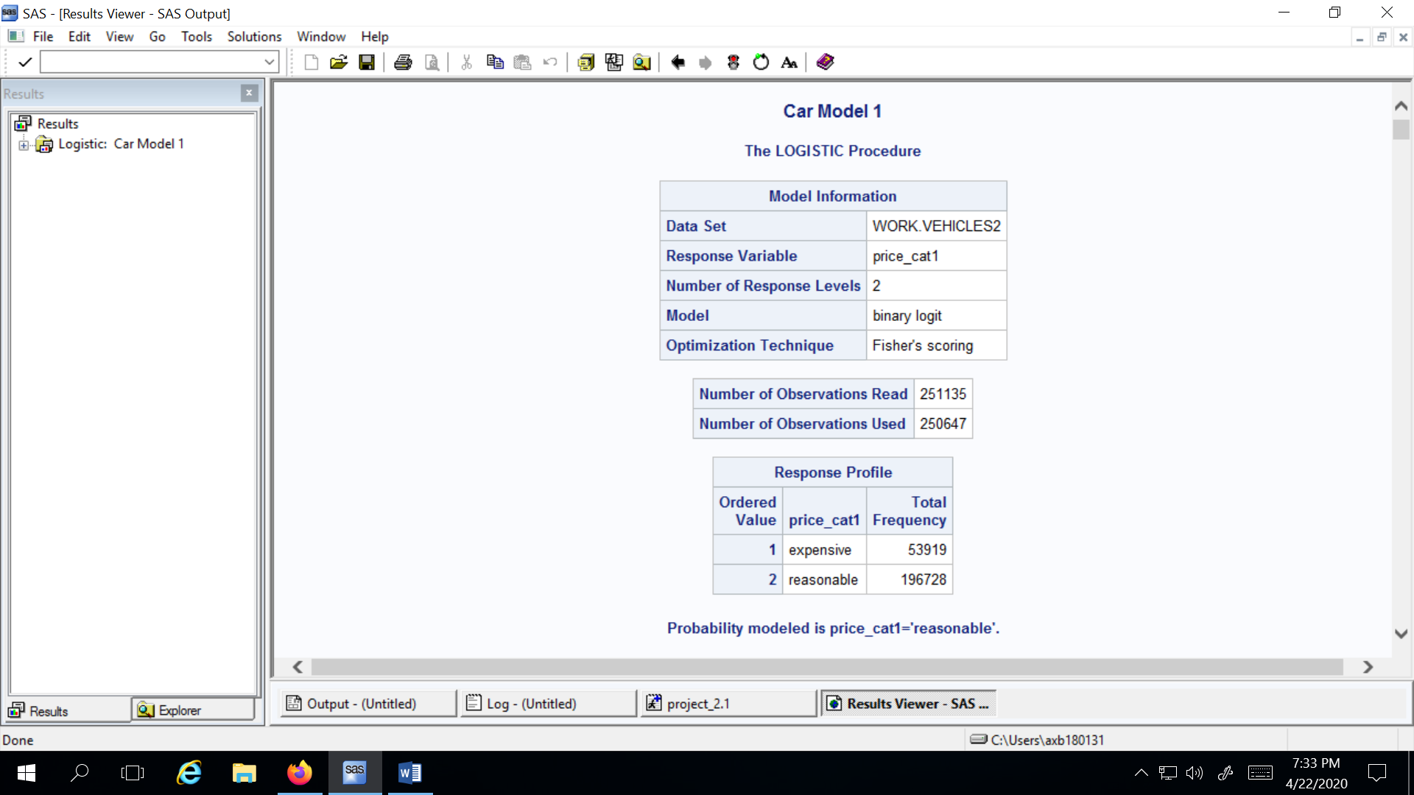

Figure 17

As we can see from the picture above, the total number of observations read are 251136 and the total number of observations used are 250647. There are 53919 vehicles in the expensive category and 196728 vehicles in the reasonable category. Probability modeled is price_cat1 = ‘reasonable’.

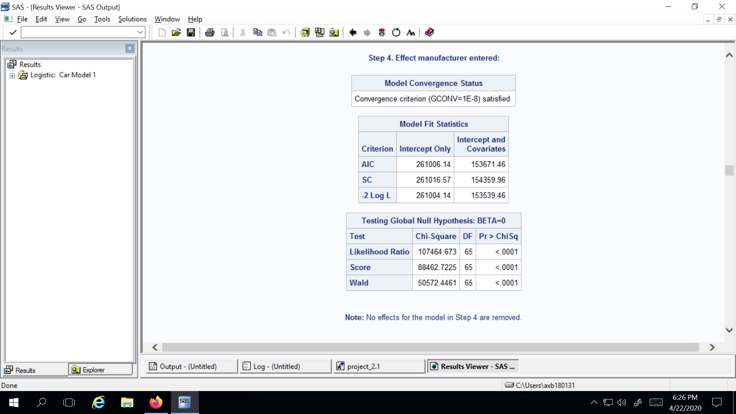

Figure 18

None of the predictor variables have been removed in the stepwise selection and the overall model is significant as per the p-value of chi square tests, convergence criteria is also satisfied in this case. AIC and SBC for this model is also shown above. We also get to know from the test of global null hypothesis that overall model is statistically significant.

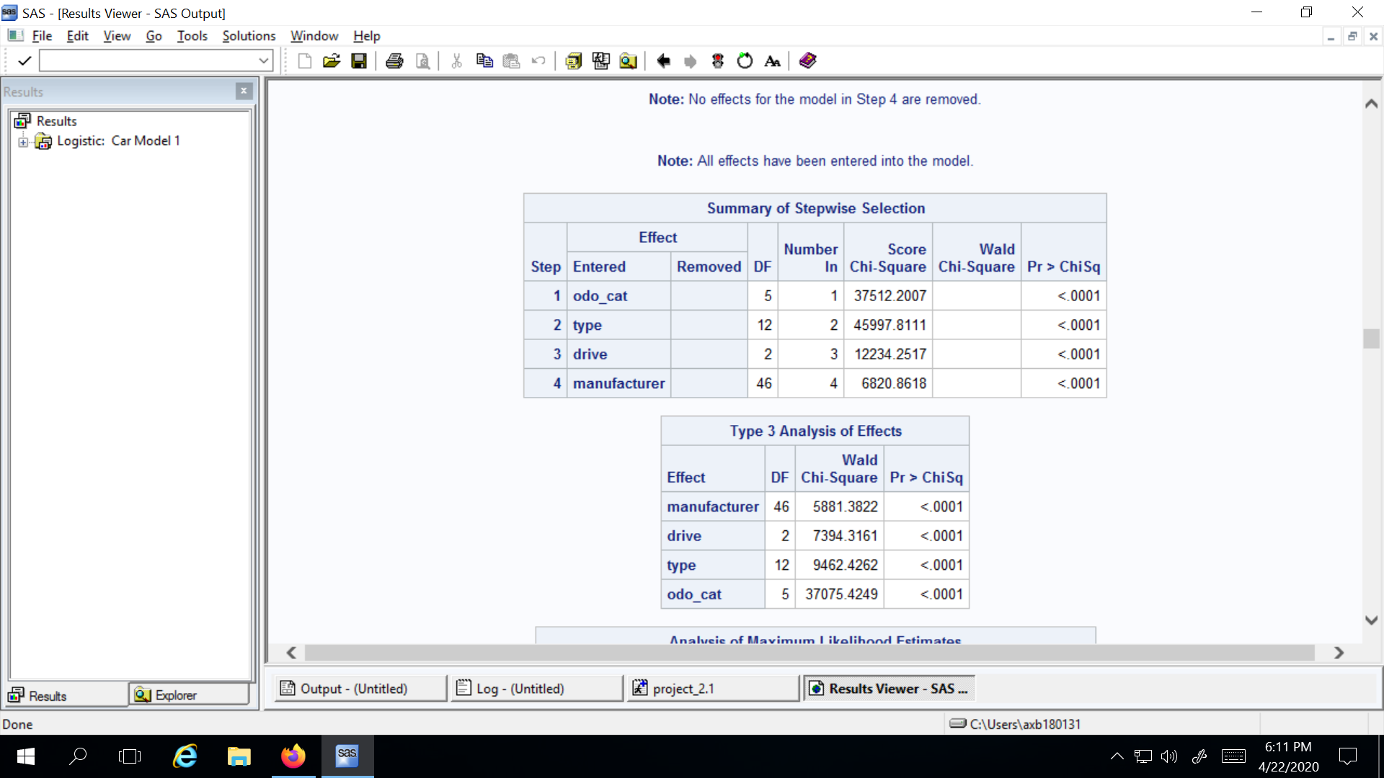

Figure 19

As per the model, all four variables used here are statistically significant. Type 3 Analysis of effects further tell us that each predictor variable is individually statistically significant.

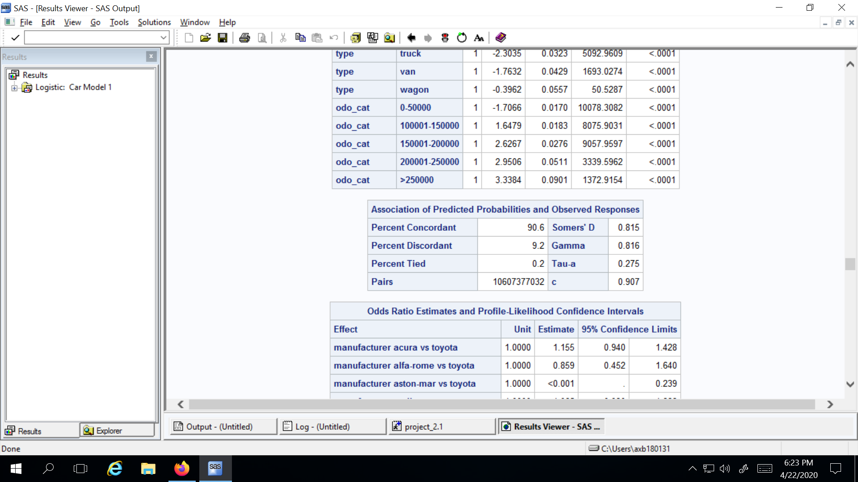

Figure 20

There are 90.6% concordant pairs in this model as shown in the picture above.

An example for interpreting the odds ratio for variables in this model is discussed below.

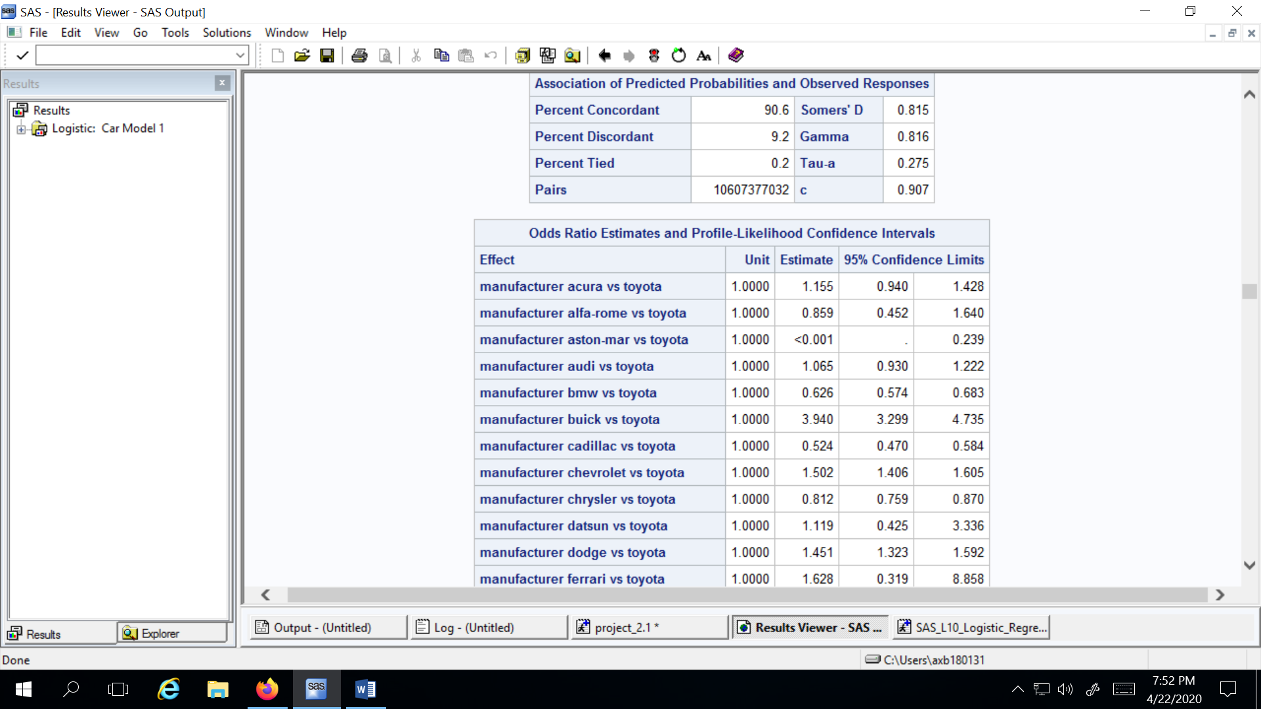

Figure 21

It can be interpreted that a vehicle from Toyota has 37.4% more odds of having a vehicle in the reasonable price category as compared to a vehicle from BMW falling in the reasonable price category.

Another example for the odds ratio is shown below.

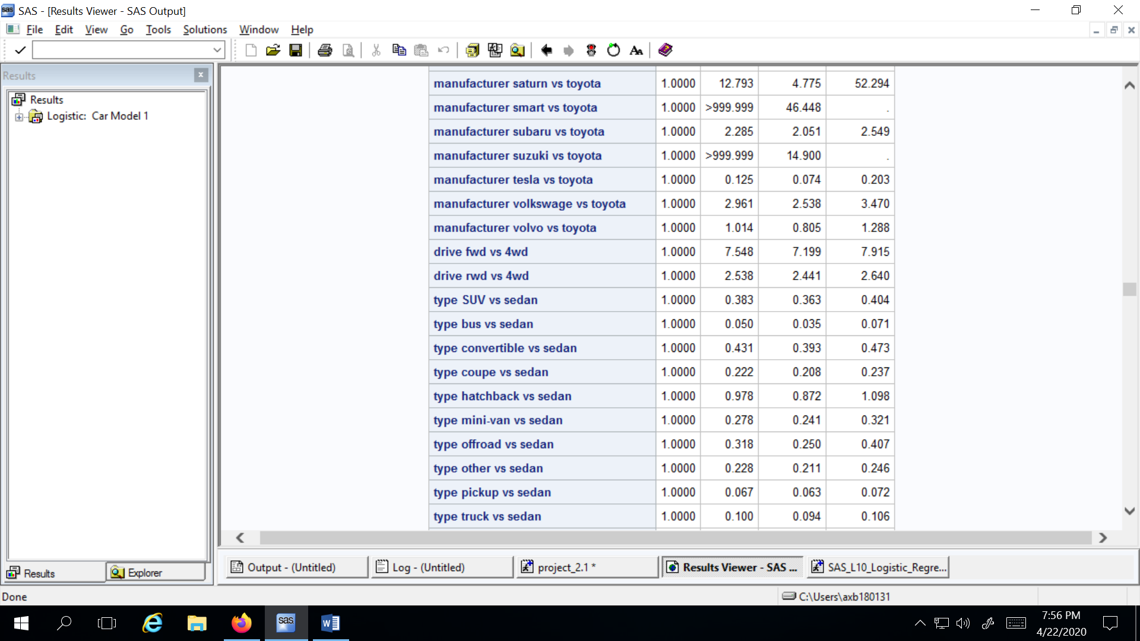

Figure 22

It can be interpreted that a vehicle of type sedan has 61.7% more odds of falling into the reasonable price category as compared to SUVs.

Next, we talk about the accuracy of this model using a simple PROC FREQ statement.

*proc freq data=work.predict;*

*tables _from_*_into_;*

*title 'Crosstabulation of Observed Responses by Predicted Responses';*

*quit;*

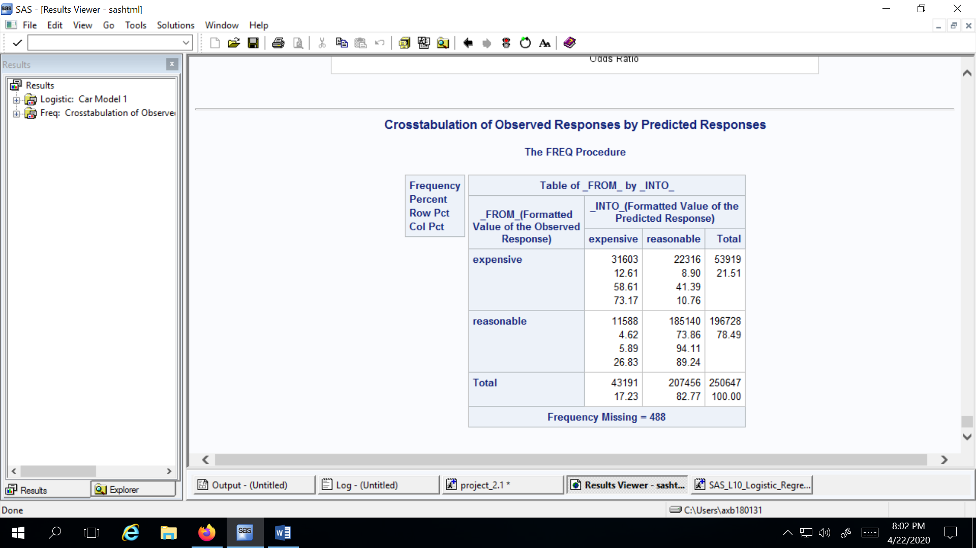

Figure 23

It can be calculated from the above picture that accuracy; (31603+185140)/250647 is 86.47%.

### NOMINAL MODEL (SECOND):

First, we look at the association between ‘price_cat’ and other predictor variables in the data set to check which variables will be a good fit for the model. The code used for this purpose is the same as the ‘price_cat1’ (binary) model. The associations are reported below.

1. Weak association between ‘cylinders’ and ‘price_cat’, with a cramer's v of 0.1280
2. Light association between ‘drive’ and ‘price_cat’, with a cramer's v of 0.2425
3. Weak association between ‘fuel’ and ‘price_cat’, with a cramer's v of 0.1613
4. Weak association between ‘manufacturers’ and ‘price_cat’, with a cramer's v of 0.2085
5. Moderate association between ‘odo_cat’ and ‘price_cat’, with a cramer's v of 0.3304
6. Light association between ‘region’ and ‘price_cat’, with a cramer's v of 0.2183
7. Weak association between ‘state’ and ‘price_cat’, with a cramer's v of 0.1544
8. Weak association between ‘title_staus’ and ‘price_cat’, with a cramer's v of 0.0591
9. Weak association between ‘transmission’ and ‘price_cat’, with a cramer's v of 0.1352
10. Moderate association between ‘type’ and ‘price_cat’, with a cramer's v of 0.2382

We have divided the price in 4 categories for this model : L1, L2, L3 and L4 and started with 8 variables.

*proc logistic data=work.vehicles_test(obs=500)*

*plots(only)=(effect(x=( drive type manufacturer odo_cat cylinders fuel title_status transmission)polybar) oddsratio (type=horizontalstat) );*

*class manufacturer(ref='toyota')*

*drive(ref='4wd')*

*type(ref='sedan')*

*odo_cat(ref='50001-100000')*

*cylinders(ref='8 cylinders')*

*fuel(ref='gas')*

*title_status(ref='clean')*

*transmission(ref='manual')*

*/ param=ref;*

*nominal1: model price_cat(ref='L1') = cylinders fuel title_status transmission drive manufacturer type odo_cat / selection=stepwise link=glogit clodds=pl;*

*output out=work.predict predprobs=i;*

*title 'Nominal Logistic Regression Model on Used Vehicles';*

*Run;*

The reference categories for each variable used here are; manufacturer-’toyota’, drive-’4wd’, type-’sedan’, odo_cat-’50001-100000’ ,cylinders-’8 cylinders’, fuel -’gas’, title_status-’clean’, transmission-’manual’ and price-’L1’.

This model was run for 500 observations to get a very basic idea about variable importance, to start with developing a better model with 4 price categories. The model was run using stepwise selection.

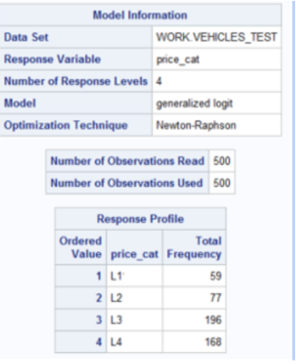

Figure 24

There were 59 vehicles in ‘L1’, 77 vehicles in ‘L2’, 196 vehicles in ‘L3’ and 168 vehicles in ‘L4’ price categories.

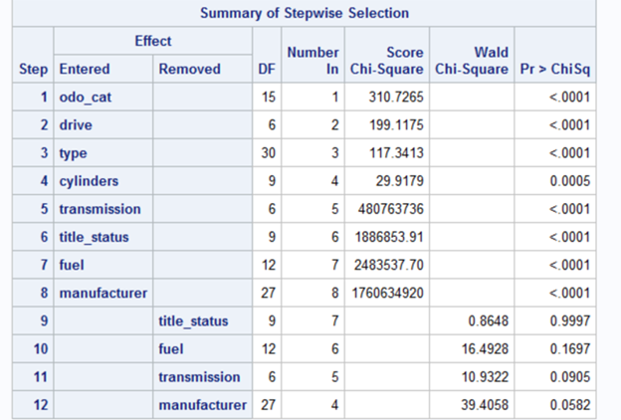

Figure 25

As we can see from this figure, the four variables title_status, fuel, transmission and manufacturer were removed from the model. As per the model result, the variables to give best results are: cylinders, drive, type and odo_cat.

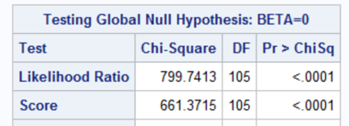

Figure 26

Convergence criteria was satisfied. The p-value for the Global Null Hypothesis is significantly low(<0.0001) which indicates that the model is significant.The p-values in Walder chi square test for all the 4 selected variables is also significantly low (<0.0001). This means all these 4 variables are significant.

An example for interpretation of odds ratio in this model is shown below.

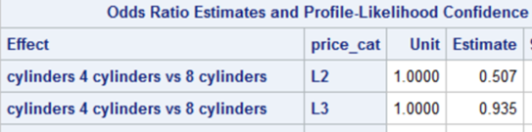

Figure

For the L2 price category, the odds of a vehicle with 4 cylinders falling in the L2 price category are 49.3% lower as compared to L1 price category when compared to a vehicle with 8 cylinders lying in the L2 price category as compared to L1 price category. Similarly, for L3 price category, the odds of a vehicle with 4 cylinders falling in L3 price category are 6.5% lower as compared to L1 price category when compared to a vehicle with 8 cylinders lying in L2 price category as compared to L1 price category.

For accuracy, using the similar code as used in the 1st model the accuracy can be calculated as shown.

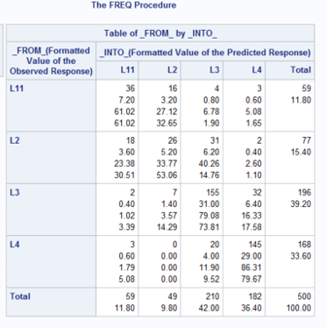

Figure 28

The accuracy for this stepwise model comes out to be : (36+26+155+145)/500 = 72.4%. Though it’s a decent accuracy statistic with so many variables in consideration, still not a reliable model because there were just 500 observations. This model is built to get an idea of important variables. Now using these variables, the next model is built with more observations.

### NOMINAL MODEL (THIRD):

This model was run using the variables which came significant from the second model- drive, type, odo_cat and cylinders.We have divided the price in 4 categories for this model : L1, L2, L3 and L4 .

*proc logistic data=work.vehicles_test(obs=50000)*

*plots(only)=(effect(x=( drive type odo_cat cylinders)polybar) oddsratio (type=horizontalstat) );*

*class drive(ref='4wd')*

*type(ref='sedan')*

*odo_cat(ref='50001-100000')*

*cylinders(ref='8 cylinders')*

*/ param=ref;*

*nominal1: model price_cat(ref='L1') = cylinders drive type odo_cat / selection=stepwise link=glogit clodds=pl;*

*output out=work.predict predprobs=i;*

*title 'Nominal Logistic Regression Model on Used Vehicles';*

*run;*

The reference categories for each variable used here are; drive-’4wd’, type-’sedan’, odo_cat- ’50001-100000’ ,cylinders-’8 cylinders’ and price-’L1’.

This model was run for 50,000 observations using stepwise selection. Convergence criteria was satisfied.

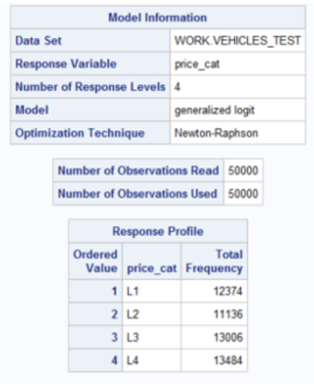

Figure 29

There were 12374 observations in ‘L1’, 11136 observations in ‘L2’, 13006 observations in ‘L3’ and 13484 observations in ‘L4’.

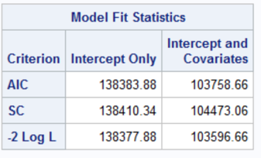

Figure 30

The AIC value for this model is: 138383.88. This value will be used to compare the results with the next model.

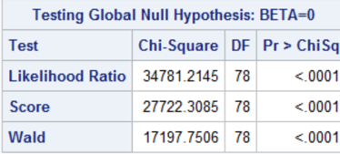

Figure 31

As per this figure the p-value for the Global Null Hypothesis is significantly low(<0.0001) which indicates that the model is significant.

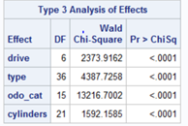

Figure 32

The p values in Walder chi square test for all the 4 selected variables is also significantly low (<0.0001). This means all these 4 variables are significant.

An example of odds ratio interpretation for this model is discussed below.



Figure 33

The odds of a vehicle with 3 cylinders to lie in the L2 price category are 0.610 (39% less) times the odds of a vehicle with 8 cylinders to lie in L2 when compared to L1 price category. Similarly, the odds of a vehicle with 3 cylinders to lie in the L3 price category are 0.724 (27.6% less) times the odds of a vehicle with 8 cylinders to lie in L3.

The accuracy for this model is calculated below.

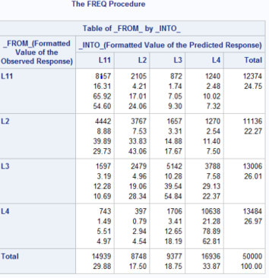

Figure 34

The accuracy for this stepwise model comes out to be: (8157+3767+5142+10638)/50000 = 55.4%. It can be seen that the accuracy has decreased significantly compared to the second model. But, it is to be taken into consideration that the observations in this model are 100 times the number of observations in the second model.

### NOMINAL MODEL (FOURTH):

This model was also run with the same four categories of price and 5 variables: drive, type, odo_cat, cylinders and transmission for all the observations. A snippet of the code used for this model is shown below.

*proc logistic data=work.vehicles_test*

*plots(only)=(effect(x=( drive type odo_cat cylinders transmission)polybar) oddsratio (type=horizontalstat) );*

*class drive(ref='4wd')*

*type(ref='sedan')*

*odo_cat(ref='50001-100000')*

*cylinders(ref='8 cylinders')*

*transmission(ref=’manual’)*

*/ param=ref;*

*nominal1: model price_cat(ref='L1') = cylinders drive type odo_cat transmission / selection=stepwise link=glogit clodds=pl;*

*output out=work.predict predprobs=i;*

*title 'Nominal Logistic Regression Model on Used Vehicles';*

*run;*

The reference categories for each variable used here are; drive- ’4wd’, type- ’sedan’, odo_cat- ’50001-100000’, cylinders- ’8 cylinders’, transmission- ‘manual’ and price- ’L1’.

This model was run for 91890 observations using stepwise selection. Convergence criteria was satisfied.

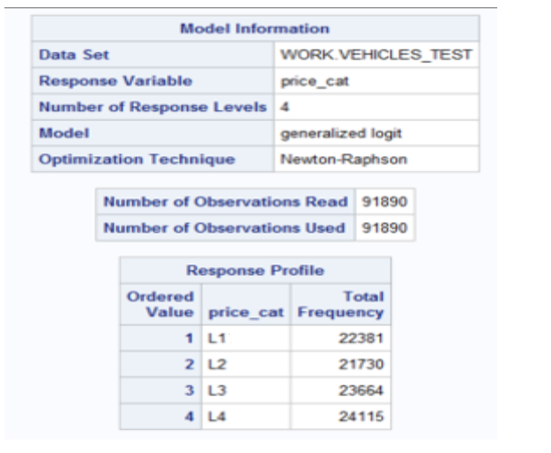

Figure 35

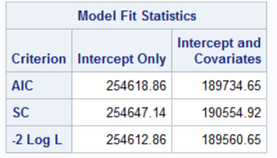

Figure 36

The AIC value for this model is: 254618.86. This value is very low as compared to the third model (138383.88). This might indicate an improvement in the model.

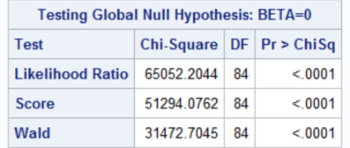

Figure 37

It can be observed from this figure that the p-value for the Global Null Hypothesis is significantly low (<0.0001) which means that the model is significant.

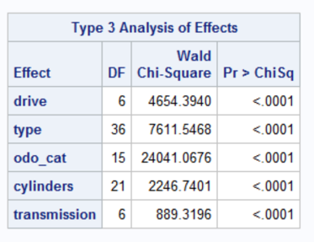

Figure 38

The p values in Walder chi square test for all the 5 selected variables is also significantly low (<0.0001). This means all these 5 variables individually are statistically significant.

An example of odds ratio interpretation for this model is discussed below.

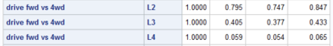

Figure 39

The odds of a car with fwd drive to lie in the L2 price category are 0.795 (20.5%less) times the odds of a car with 4wd drive to lie in the L2 price category compared to L1 price category. Similarly, the odds of a car with fwd drive to lie in the L3 price category are 0.405 (59.5%less) times the odds of a car with 4wd drive to lie in the L3 price category compared to L1 price category.

The accuracy for this model is calculated below. By exploring different number of variables, observations and even the categories of our predictor variable, we are trying to develop a reliable model with best accuracy.

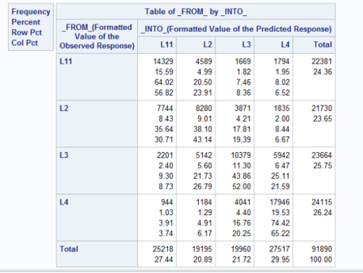

Figure 40

The accuracy for this stepwise model comes out to be: (14329+8280+10379+17946)/91890 = 55.4%. It is observed that the accuracy of this model remains almost the same as that of the previous one.

### ORDINAL MODEL-Adjacent Category-Stepwise selection (FIFTH):

Before running any sort of ordinal model, we will first look at the association of all variables with ‘price_cat’ to understand which variables could be a good fit for the model. Mantel Haenszel chi square test and spearman correlation coefficient was used for this purpose.

1. Light association between ’cylinders’ and ‘price_cat1’, with correlation coeff. of 0.1576
2. Light association between ‘drive’ and ‘price_cat1’, with correlation coeff. of 0.2061
3. Weak association between ‘manufacturer’ and ‘price_cat1’, with correlation coeff. of 0.0296
4. Light association(negative) between ’odo_cat’ and ‘price_cat1’, with correlation coeff. of -0.1801.
5. Weak association between ‘region’ and ‘price_cat1’, with correlation coeff. of 0.0139
6. Weak association between ‘state’ and ‘price_cat1’, with correlation coeff. of 0.0016
7. Weak association between ‘type’ and ‘price_cat1’, with correlation coeff. of 0.0173
8. Weak association(negative) between ‘model’ and ‘price_cat1’, with correlation coeff. of 0.025

This model was run with 7 variables. A snippet of the code used for this model is shown below.

*ods graphics on;*

*proc logistic data=work.vehicles1*

*plots(only)= ( oddsratio (type=horizontalstat) );*

*class cylinders (ref='4 cylinders')*

*title_status (ref='clean')*

*paint_color ( ref='red')*

*type (ref='SUV')*

*fuel(ref = 'gas')*

*transmission(ref = 'automatic')*

*drive(ref = 'fwd')*

*/ param=ref;*

*ordinal1: model price_cat =cylinders type paint_color title_status drive transmission fuel/*

*LINK=ALOGIT clodds=pl maxiter=1000 selection=stepwise ;*

*output out=work.predict predprobs=i;*

*title 'stepwise adj Log Model for all data price_cat =cylinders type paint_color title_status drive transmission fuel ';*

*run;*

*ods graphics off;*

The reference categories for each variable used here are; drive- ’fwd’, type- ’SUV’, cylinders- ’4 cylinders’, transmission- ’automatic’, title_status- ’clean’, paint_color- ’red’, fuel-’gas.’

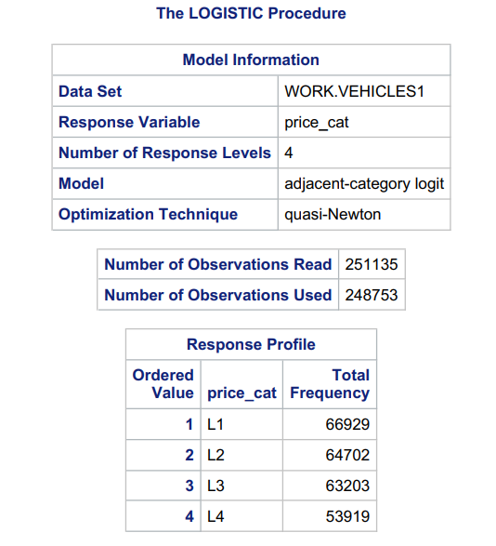

Figure 41

There are a total of 248753 observations used. There are 66929 observations in ‘L1’, 64702 observations in ‘L2’, 63203 observations in ‘L3’, 53919 observations in ‘L4’.

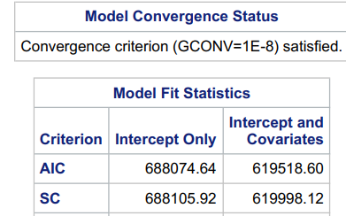

Figure 42

The convergence criteria for this model is satisfied. The AIC for this model is 688074.64 and SBC is 688105.92.

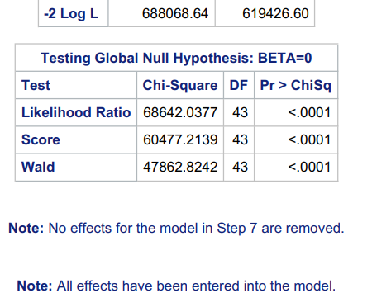

Figure 43

The model is significant as observed from this figure, the p-value for the Global Null Hypothesis is significantly low (<0.0001).

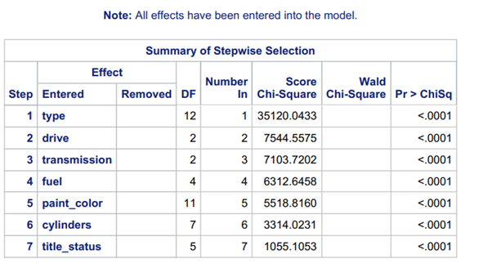

Figure 44

The model was run using stepwise selection and all the variables were retained.

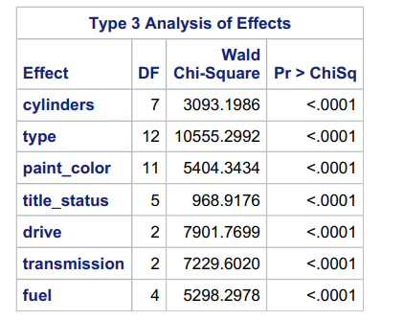

Figure 45

The Type 3 Analysis of effects further tells us that each variable is statistically significant.

An example of odds ratio interpretation for this model is discussed here.

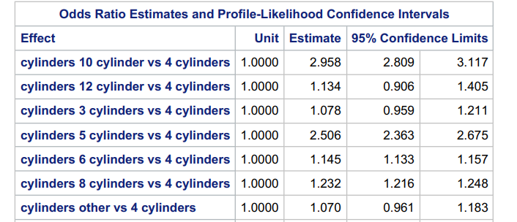

Figure 46

Odds for vehicles with 10 cylinders are 2.958 times(195.8% more) the odds of vehicles with 4 cylinders to be present in the higher adjacent price category.

The approach to calculate the accuracy for this model is the same as previous models.

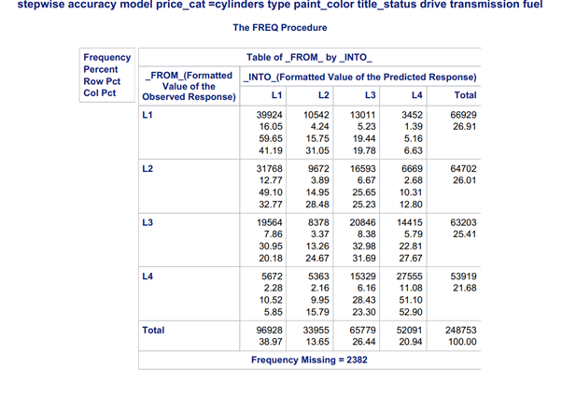

Figure 47

The accuracy for this stepwise model comes out to be 39.39% [(39924+9672+20846+27555)/248753].

### ORDINAL MODEL-Adjacent Category (SIXTH):

To make some improvements to the previous model, the observations of the top 10 manufacturers and states with most frequency are taken into consideration for modeling.

.

*ods graphics on;*

*proc logistic data=work.vehicles_test*

*plots(only)= ( oddsratio (type=horizontalstat) );*

*class cylinders (ref='4 cylinders')*

*title_status (ref='clean')*

*paint_color ( ref='red')*

*type (ref='SUV')*

*odo_cat (ref = '200001-250000')*

*state (ref = 'tx')*

*manufacturer (ref = 'ford')*

*fuel (ref ='gas')*

*transmission (ref = 'automatic')*

*/ param=ref;*

*ordinal1: model price_cat =cylinders type odo_cat paint_color title_status state manufacturer transmission fuel/*

*LINK=ALOGIT clodds=pl maxiter=1000 selection=stepwise ;*

*output out=work.predict predprobs=i;*

*title 'adj Logistic Regression Model stepwise';*

*run;*

As this model is similar to the 5th model but with cleaner and better data by selecting top 10 manufacturers and states, all the model parameters remain the same and we have included manufacturer reference as ‘ford’ and state reference as ‘tx’. The total number of observations used is 91062.

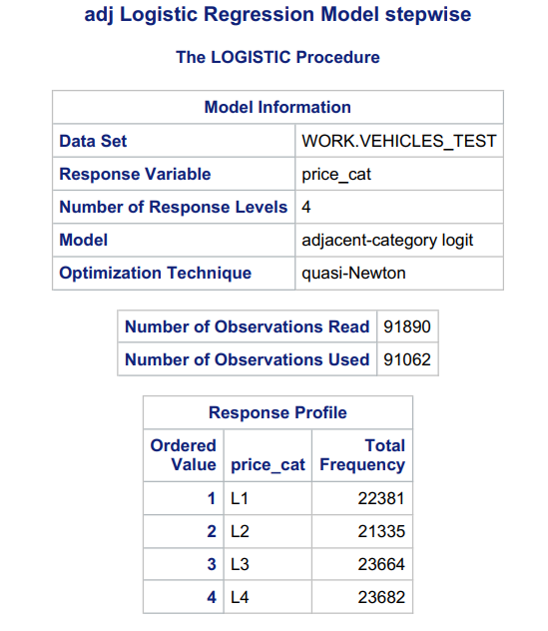

Figure 48

Number of observations for ‘L1’ are 22381, ‘L2’ are 21335, ‘L3’ are 23664, ‘L4’ are 23682.

’

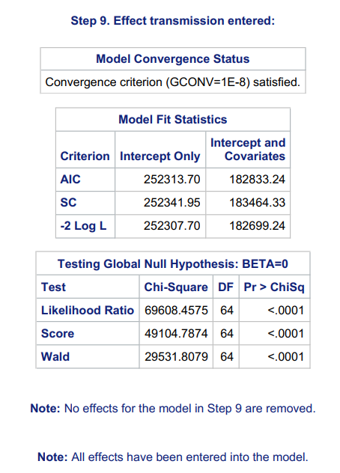

Figure 49

The convergence criteria for this model has been satisfied. The model has an AIC value of 252313.70 and SBC value of 252341.95. The test for Global Null Hypothesis tells us that the overall model is significant.

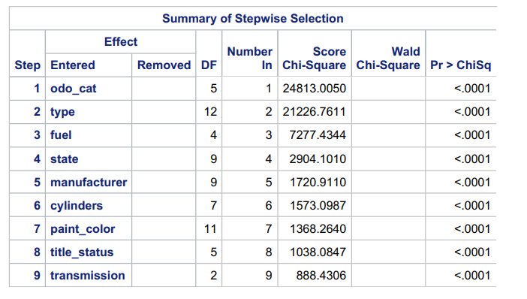

Figure 50

None of the variables are removed through stepwise selection which were entered upon modeling, and every variable is observed to be statistically significant.

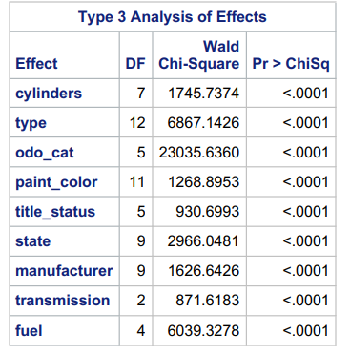

Figure 51

The Type 3 Analysis of effects further confirms that each variable in this model is statistically significant.

An example of odds ratio interpretation for this model is discussed here.

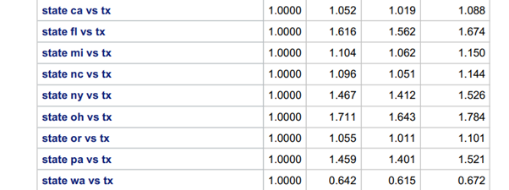

Figure 52

The vehicles in state of North Carolina has 1.096 times (9.6%) more odds of falling into adjacent higher price category as compared to the vehicles in state of Texas. (Figure 52)

The accuracy for this model is calculated to check if there was an improvement on selecting a sample from our data for top 10 manufacturers and state by frequency.

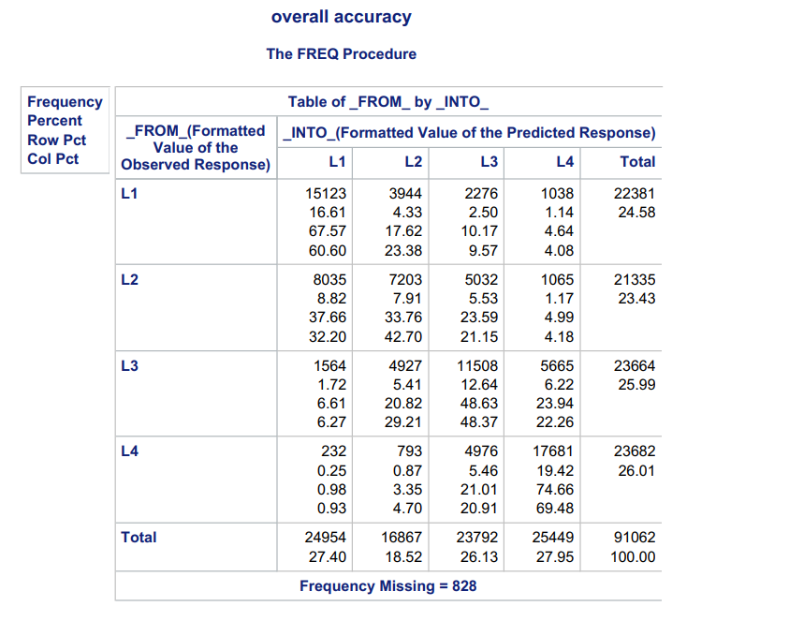

Figure 53

The accuracy here comes out to be 57.73% [(15123+ 7203+ 11508+ 17681)/91062]. It is observed that the accuracy increased from 39.39% to 57.73% by taking a better subset of data, which is approximately 18% improvement.

### ORDINAL MODEL- Cumulative (SEVENTH):

As a different category of price was used for this model, association of variables in the dataset were checked with ‘price_cat’. Mantel Haenszel chi square test and spearman correlation coefficient were used for this purpose.

This model was run using 8 variables. The price categories used in this model are different than the ones used in nominal, adjacent category ordinal and binary models. Here, price has been divided as ‘Low priced’ for vehicles costing less than $5000, ‘Reasonable’ for vehicles costing between $5000 and $15000, expensive for vehicles costing more than $15000.

1. Light association between ‘odo_cat’ and ‘price_cat’, with correlation coeff. of 0.1738
2. Weak association between ‘manufacturer’ and ‘price_cat’, with correlation coeff. of 0.1738
3. Light association between ‘drive’ and ‘price_cat’, with correlation coeff. of 0.1404
4. Light association between ‘odo_cat’ and ‘price_cat’, with correlation coeff. of 0.1738
5. Weak association(negative) between ‘type’ and ‘price_cat’, with correlation coeff. of -0.0088
6. Weak association(negative) between ‘paint_color’ and ‘price_cat’, with correlation coeff. of -0.0305
7. Weak association between ‘title_status’ and ‘price_cat’, with correlation coeff. of 0.0584
8. Light association between ‘fuel’ and ‘price_cat’, with correlation coeff. of 0.1126
9. Weak association(negative) between ‘transmission’ and ‘price_cat’, with correlation coeff. of -0.0714

The reference categories for each of the variables used are as follows; type- ‘SUV’, manufacturer- ‘ford’, state- ‘ca’, cylinders- ‘4 cylinders’, drive- ‘4wd’, odo_cat- ‘100001-150000’, paint_color- ‘white’ and price_cat- ‘Low priced’. A snippet of the code used for this model is shown here.

*proc logistic data=work.vehicles_test*

*plots(only)=(effect (individual showobs=yes)*

*oddsratio(type=horizontalstat));*

*class price_cat*

*type(ref='SUV')*

*manufacturer(ref='ford')*

*state(ref='ca')*

*cylinders(ref='4 cylinders')*

*drive(ref='4wd')*

*odo_cat(ref='100001-150000')*

*paint_color(ref='white') ;*

*model price_cat(ref='Low priced') = type manufacturer state cylinders drive odo_cat paint_color /selection=forward clodds=pl;*

*title 'Cumulative Logistic Regression';*

*run;*

*quit;*

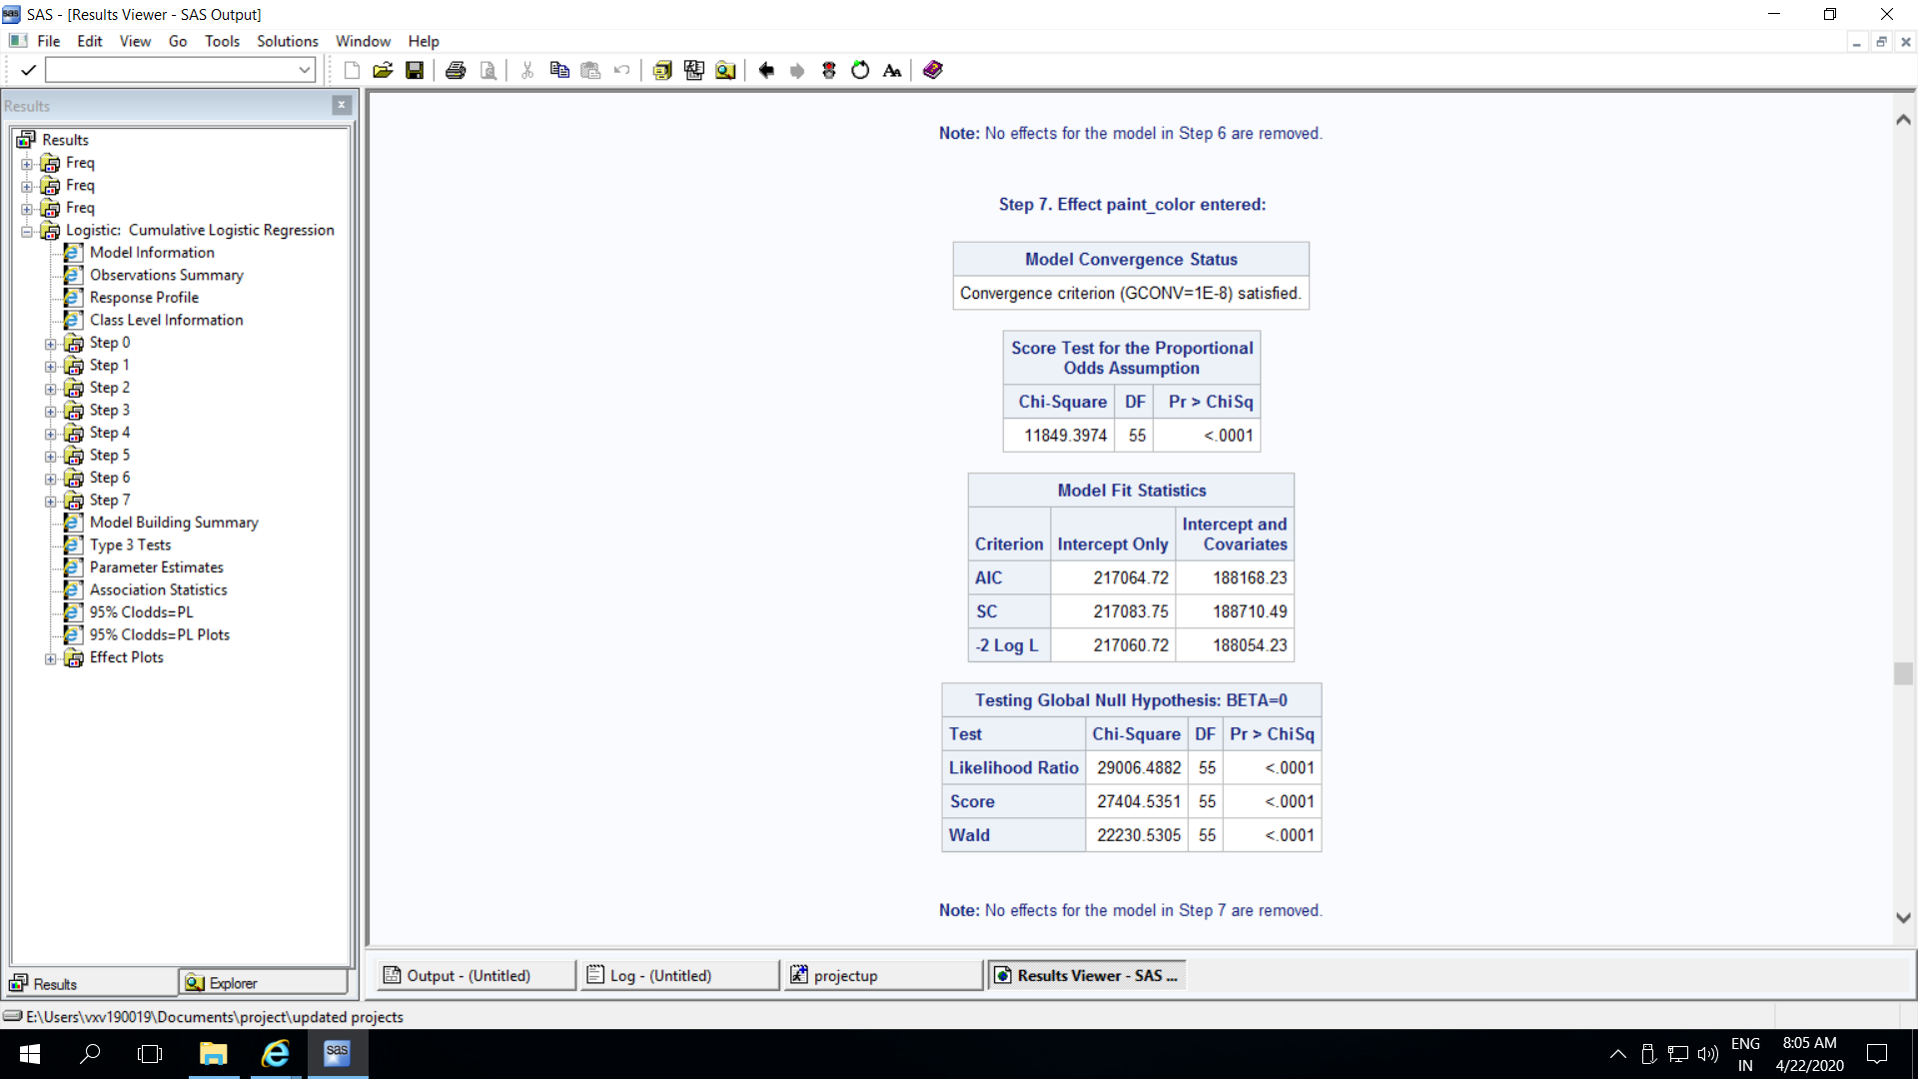

Figure 54

Forward selection criteria has been used for this model. All the variables are kept in the final model. The convergence criteria has been satisfied, whereas the assumption for proportional odds is violated. This model has a AIC value of 217062.72 and SBC value of 217083.72. It is also observed that the test for Global Null Hypothesis comes out to be significant, which means that the overall model is statistically significant.

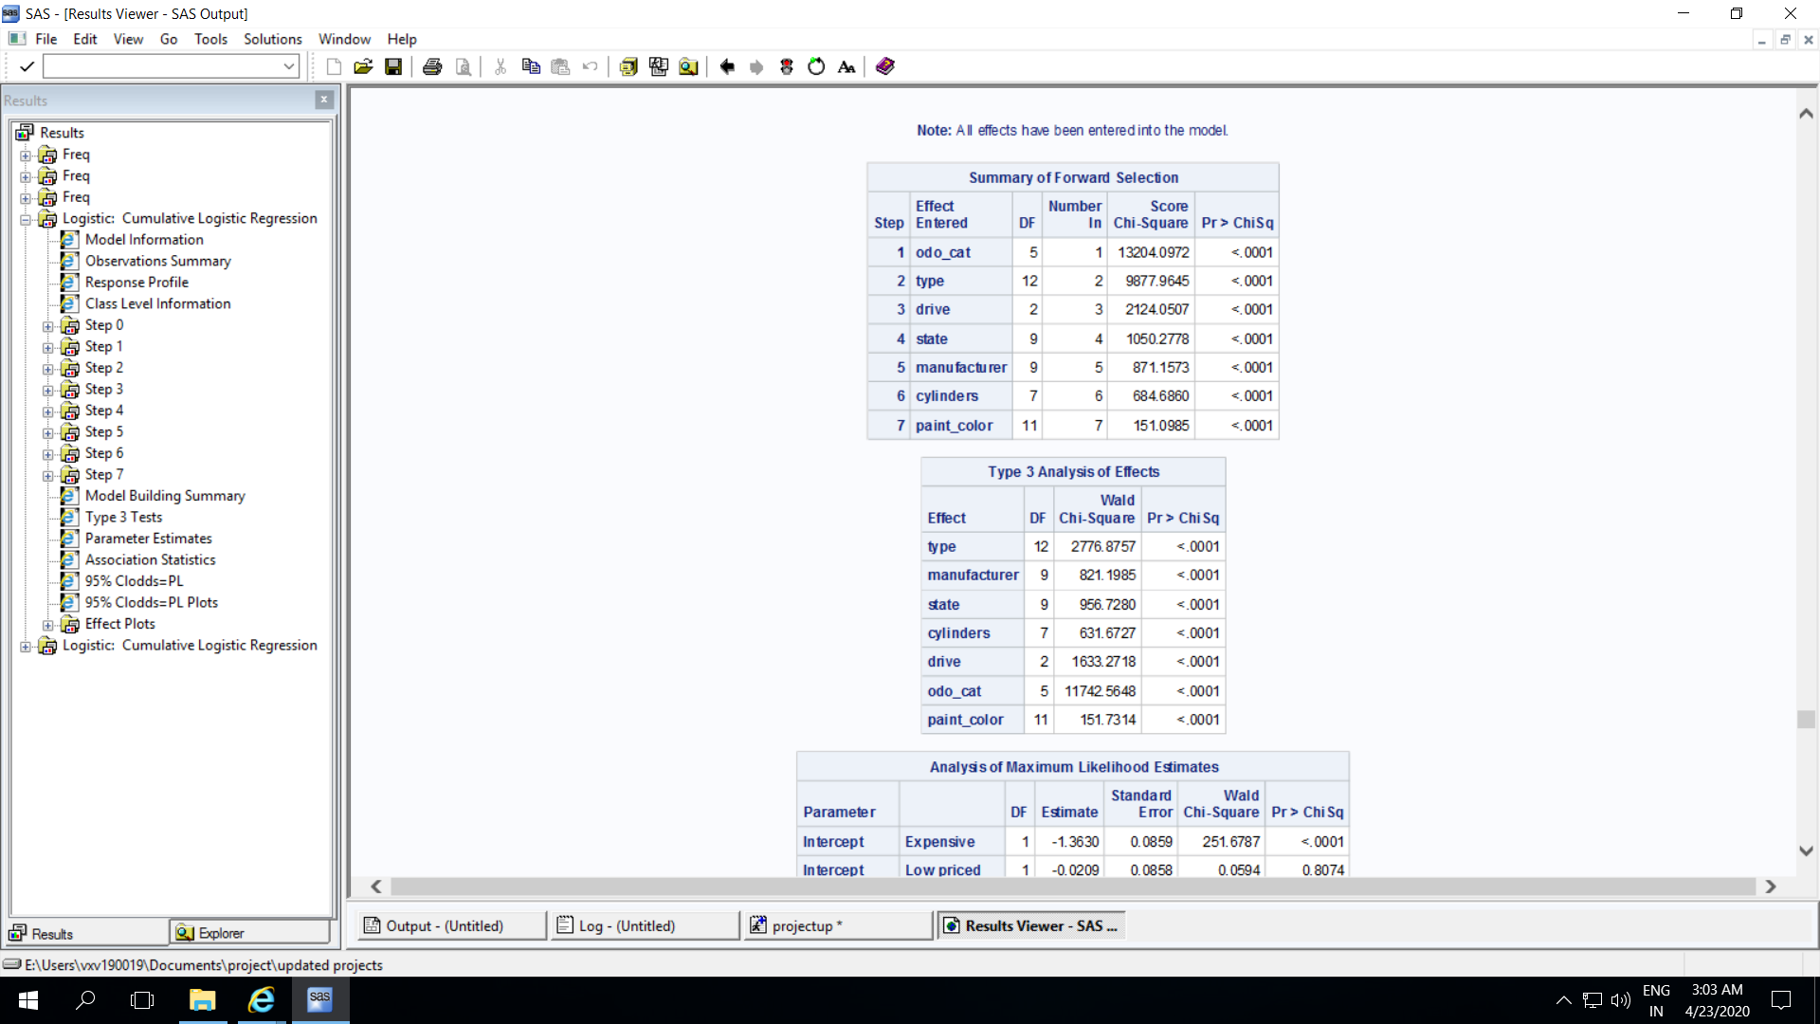

Figure 55

As per the model, all the eight variables used here are statistically significant. Type 3 Analysis of effects further tells us that each variable is individually statistically significant. (Figure 55)

An example for interpreting the odds ratio for variables used in this model is shown below.

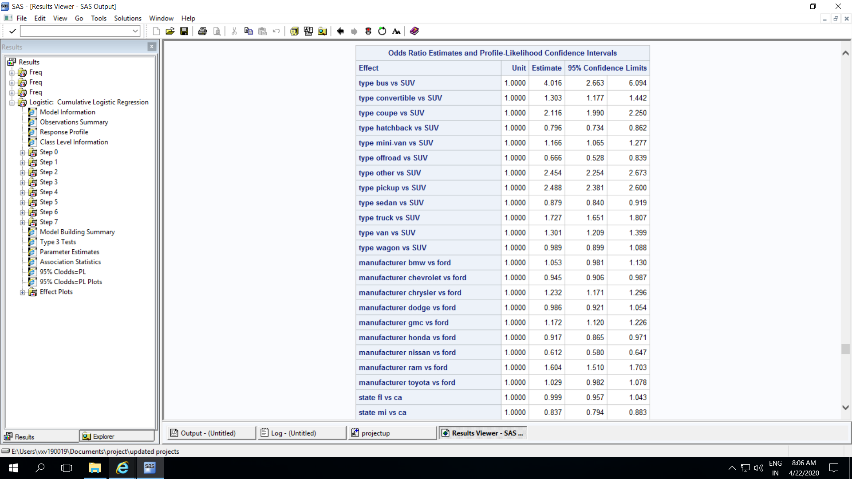

Figure 56

It can be interpreted that the odds of a bus having a higher price are 4.016 times greater than the odds of a SUV having higher price. Similarly, the odds of a convertible vehicle having a higher price are 1.303 times (30.3%) greater than the odds of a SUV having higher price.

Another example for interpreting the odds ratio for variables used in this model is shown here.

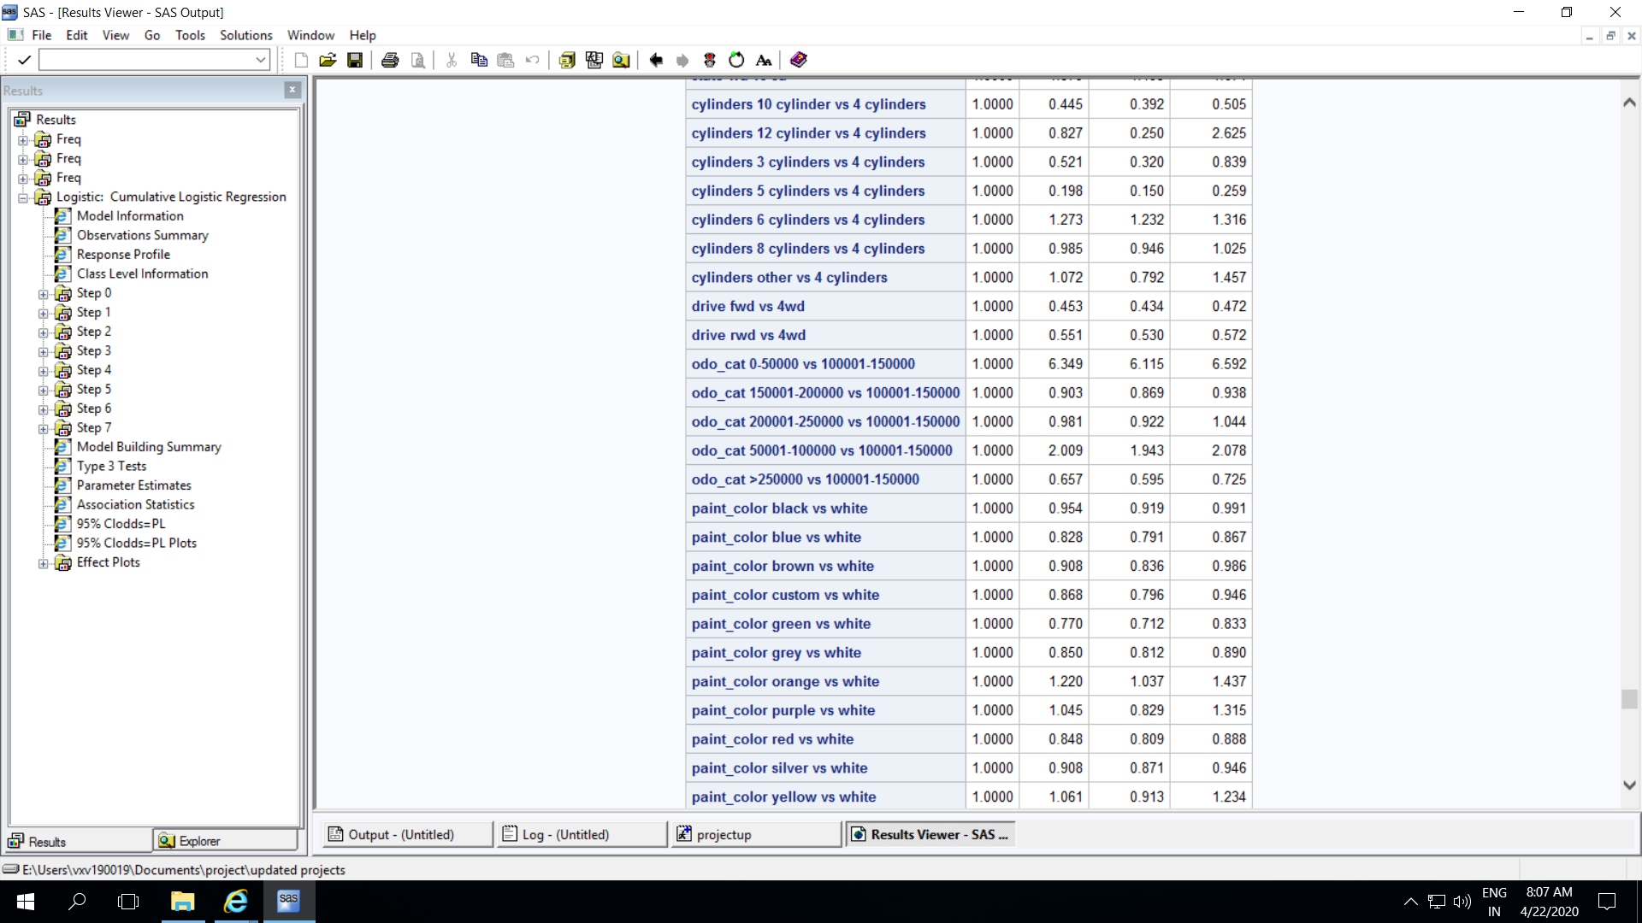

Figure 57

The odds of a 4wd vehicle has 54.7% more odds of having a vehicle in a higher price category as compared to a fwd vehicle having a higher price. Similarly, a 4wd vehicle has 44.9% more odds of having a vehicle in a higher price category as compared to a fwd vehicle having a higher price.

Next, we check the accuracy of this model using a similar approach as the previous models.

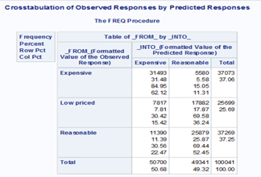

Figure 58

The accuracy for this model is; (31493+25789)/100041 = 57.25%. (Figure 58)

As the proportional odds assumption in this model was violated, another model was run using the unequal slopes option in the PROC LOGISTIC statement. A snippet of the code used for this purpose is shown here.

*proc logistic data=work.vehicles_test*

*plots(only)=(effect (individual showobs=yes)*

*oddsratio(type=horizontalstat));*

*class price_cat*

*type(ref='SUV')*

*manufacturer(ref='ford')*

*state(ref='ca')*

*cylinders(ref='4 cylinders')*

*drive(ref='4wd')*

*odo_cat(ref='100001-150000')*

*paint_color(ref='white') ;*

*model price_cat(ref='Low priced') = type manufacturer state cylinders drive odo_cat paint_color / unequalslopes = (manufacturer odo_cat type state cylinders) selection=stepwise clodds=pl;*

*output out=work.predict predprobs=i;*

*title 'Cumulative Logistic Regression';*

*run;*

The accuracy for this model can be calculated from the table below.



Figure 59

The accuracy for this model is; (28160+21873)/100041 = 50.02%.

# CONCLUSION

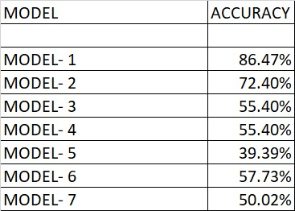

Figure 60

In this analysis, price was the target variable. Price was divided into 3 types of categories:

* Binary (Reasonable and Expensive)
* 4 categories (L1, L2, L3, L4)
* 3 categories (Low priced, reasonable, expensive)

After running different type of logistic models, it is observed that the model with binary categories for price had the maximum accuracy (86.47%). As the price was segmented into more categories using the percentile distribution, the accuracy of the models somewhat decreased.

However, upon choosing a sample out of our data from top 10 manufacturers and states (which represent almost 60-70% of our data), an increase of approximately 18% in the accuracy was observed with other variables remaining the same.

For cumulative logistic, it is observed that the accuracy of the model when the proportional odds assumption violated is more than the accuracy of the model where the option of unequal slopes is used to account for the disproportionate odds.

Nominal logistic models have the slightest improvement overall when different variables are used and there is not a big difference in accuracy when a small number of observations are used as compared to the whole dataset (Model 3 & 4).